eCMS MANUAL

Duty Free Quota Application

Department of Revenue and Customs
Ministry of Finance
Contents
1. Introduction 3
2. Duty Free user registration 3
3. Duty Free Quota Application 7
3.1 New Application 7
4. Duty Free Process Flow 10
4.1 Duty-free warehousing declaration. 10
4.2 Duty free sales for non-Quota Holder 14
4.3 Duty-free Sales for Quota Holder 17
4.4 Duty Free Sales at Airport 21
4.5 Duty Free Consumption on Board 23
4.6 Duty Free Sales on Board 26

Introduction
FE use the Duty-Free module to apply for the duty-free quota and create the declaration accordingly.
Duty free user is registered as Trader into the eCMS

Duty Free user registration
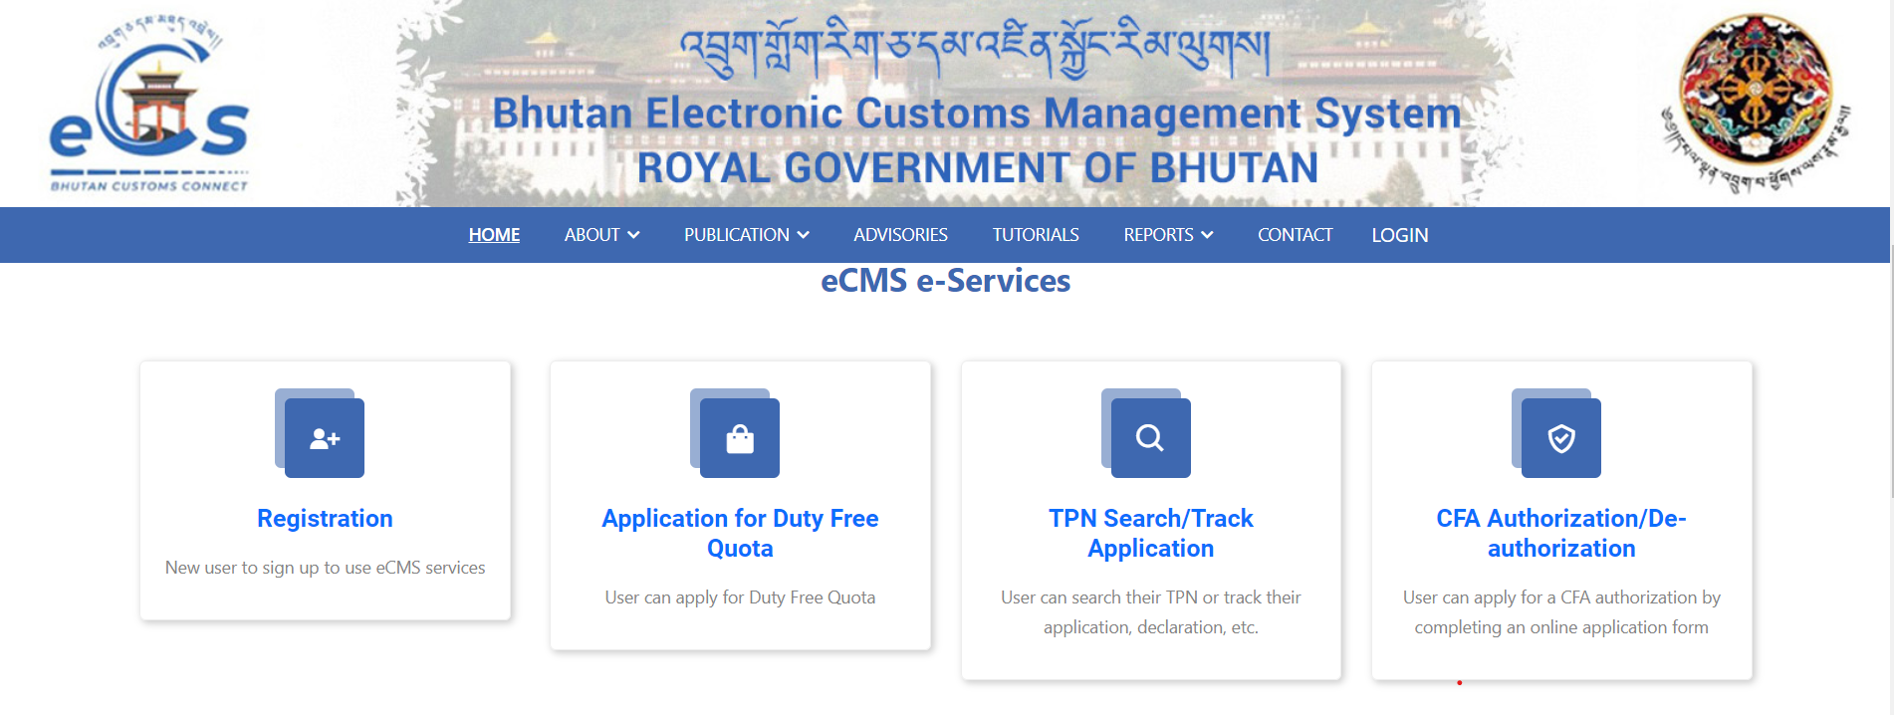
- Open browser, you can use any from the list (Microsoft Edge, Google Chrome,Safari)
- Type the url: www.ecms.gov.bt
- Scroll to the part of the page with heading eCMS e-Services
- Click on Registration

- OTP Authentication

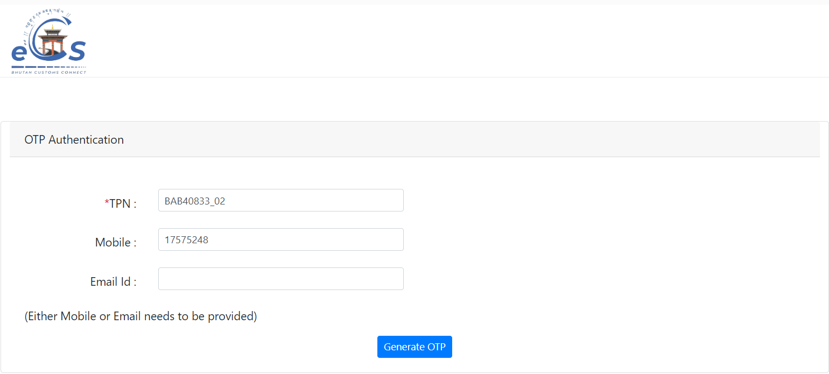

- Type in TPN
- Type in either of your registered Mobile number/ email address.
- Click on Generate OTP
- OTP will be sent to the provided mobile number /email.

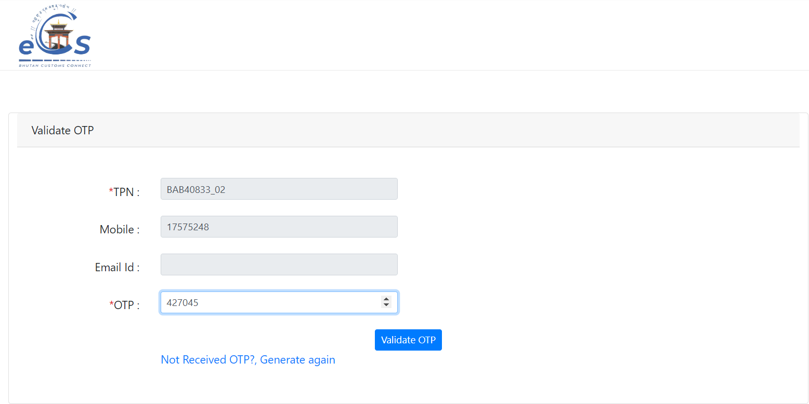

Validation takes place and new screen with the OTP label pops in.
- Type in the OTP received.
- Click on Validate OTP

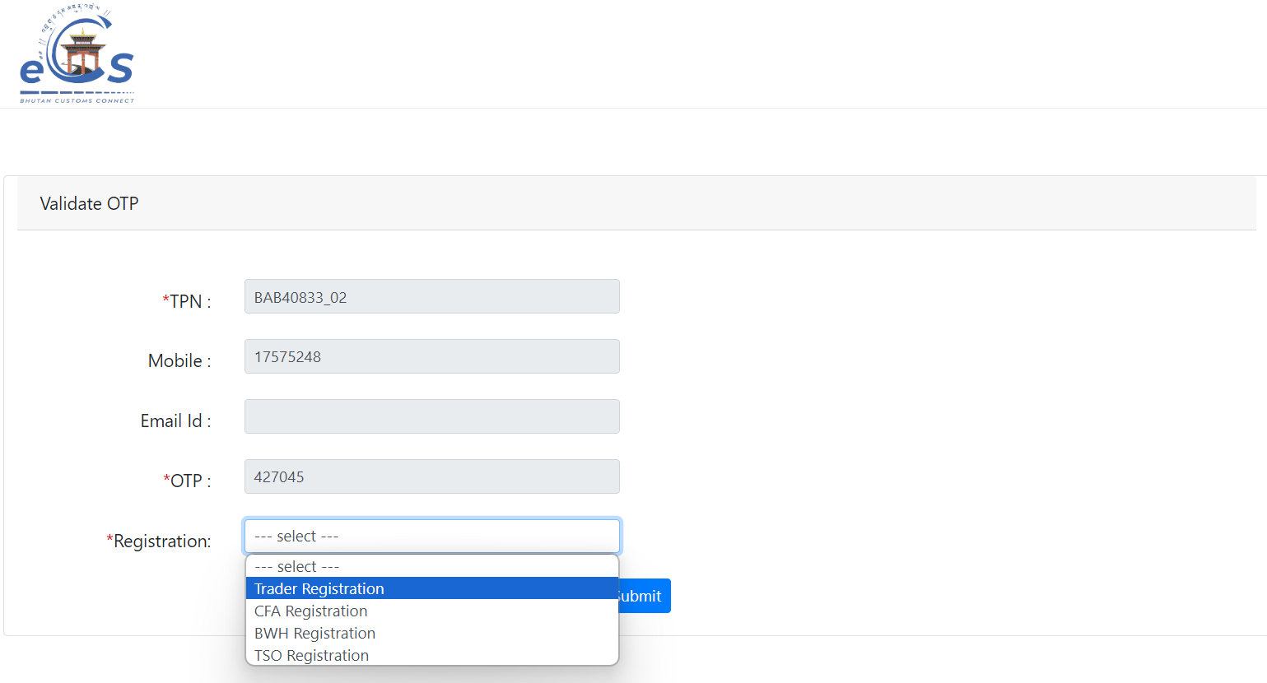

Once OTP is validated new screen with the Registration Label will be seen as above.

- Click on the box.
- Dropdown will appear.
- Select Trader
- Click on Submit

Note: Provide the mandatory details marked with * under each tab to complete the registration process.

  - Party Details

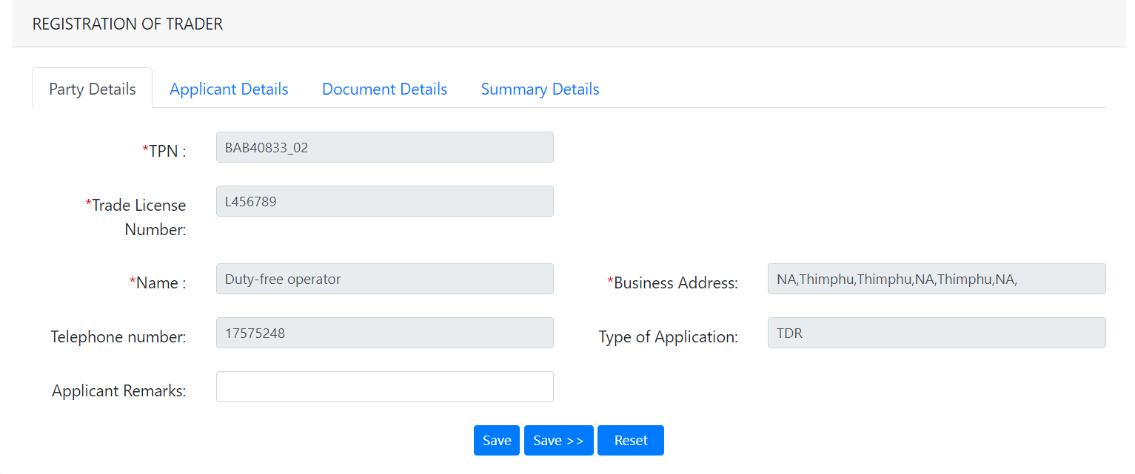
- Data here are auto populated as the TPN was validated initially.
- Review the date in each field, if any mismatch please contact the eCMS team before you proceed with the registration process.
- If all the data here is correct, Save the same and move to next tab

  - Application Details

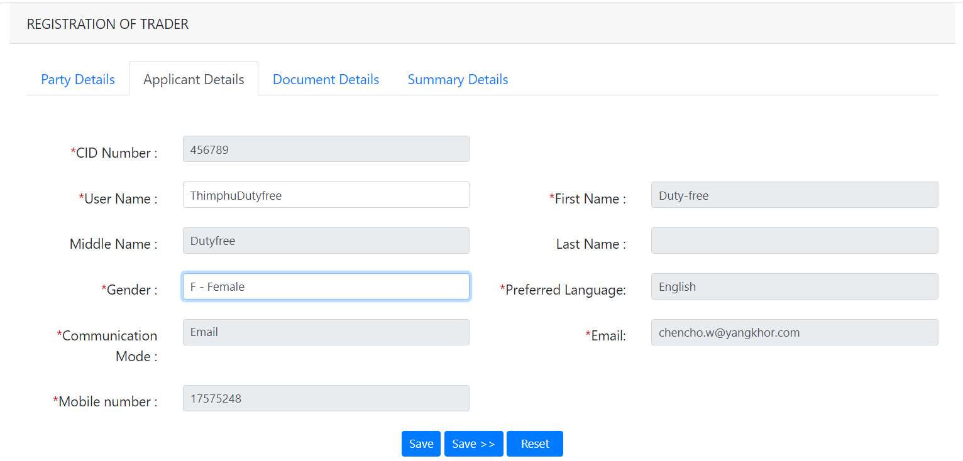

- Need to provide the User Name (which will be used for login into the system)
- Select the gender.
- Rest of the data gets auto populated.
- Click on Save

  - Documents Details
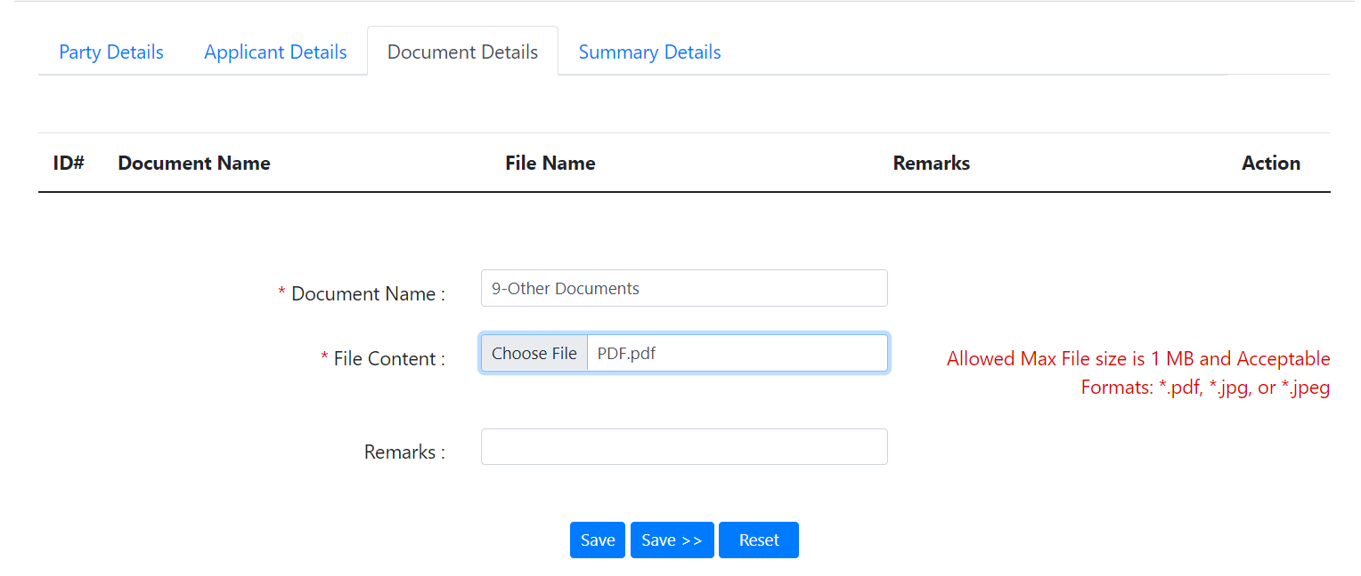
- Need to upload the document mandatory for registration if stated.
- Once uploaded Click Save.

  - Summary

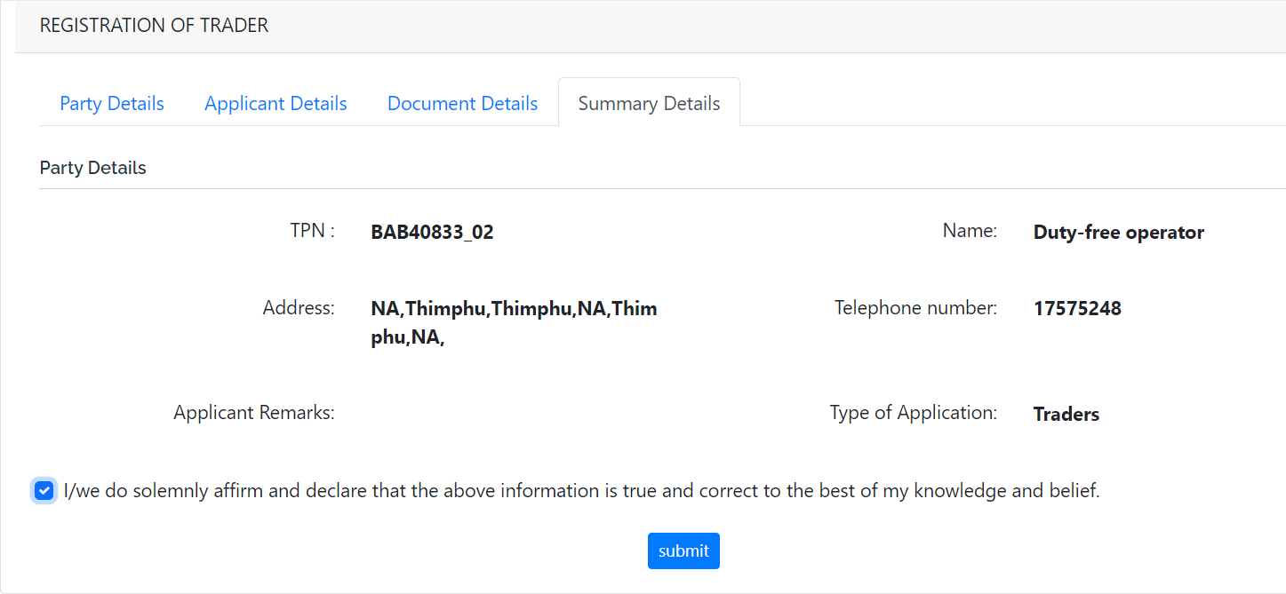
- Provides the details for final review before you agree the terms.
- Click on Submit
- Registration Number gets generated, this number can be used for tracking your application through Track Application under the eCMS Services.

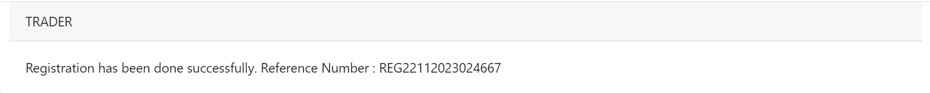
Note: Once the application is approved the application will receive a mail with the user credentials (user name , password ), user name will be the one that the applicant mentioned in the application and password will default , which needs to be changed in first login

Duty Free Quota Application

Duty free quota application can be applied as follows:
- Open browser, you can use any from the list (Microsoft Edge, Google Chrome,Safari)
- Type the url: www.ecms.gov.bt
- Scroll to the part of the page with heading eCMS e-Services
- Click on Application for Duty Free Quota

New Application
- Application details
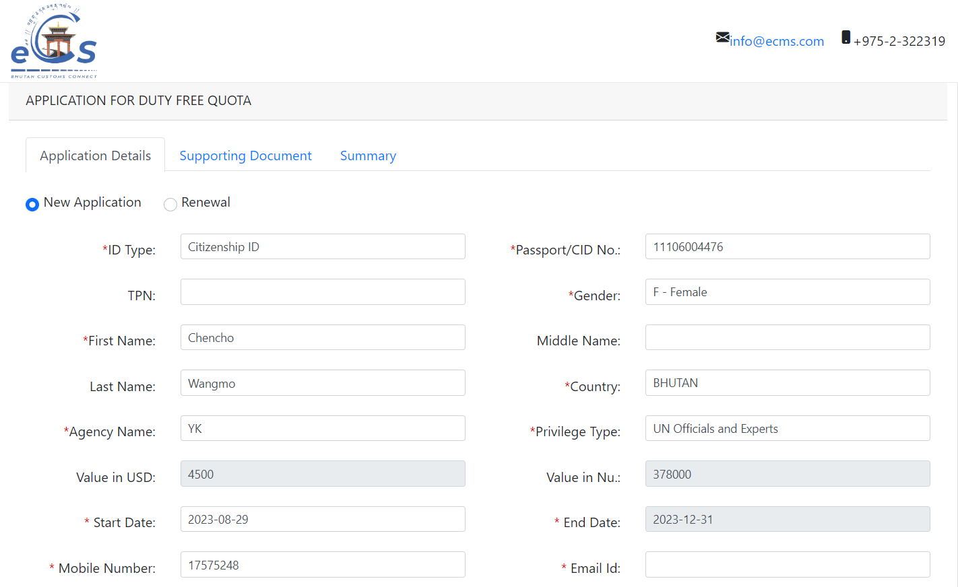
- Select ID Type
- Provide the Passport/CID No
- Type in TPN
- Select Gender
- Type In First Name
- Type Middle Name (if you have)
- Type in Last Name
- Select Country
- Type in Agency Name
- Select Privilege Type
- Once the Privilege Type is selected the Value In USD and Value in Nu gets populated as per the quota granted
- Provide the Start Date
- End date gets auto generated
- Type in valid Mobile Number.
- Type in valid email address.

- Support Document

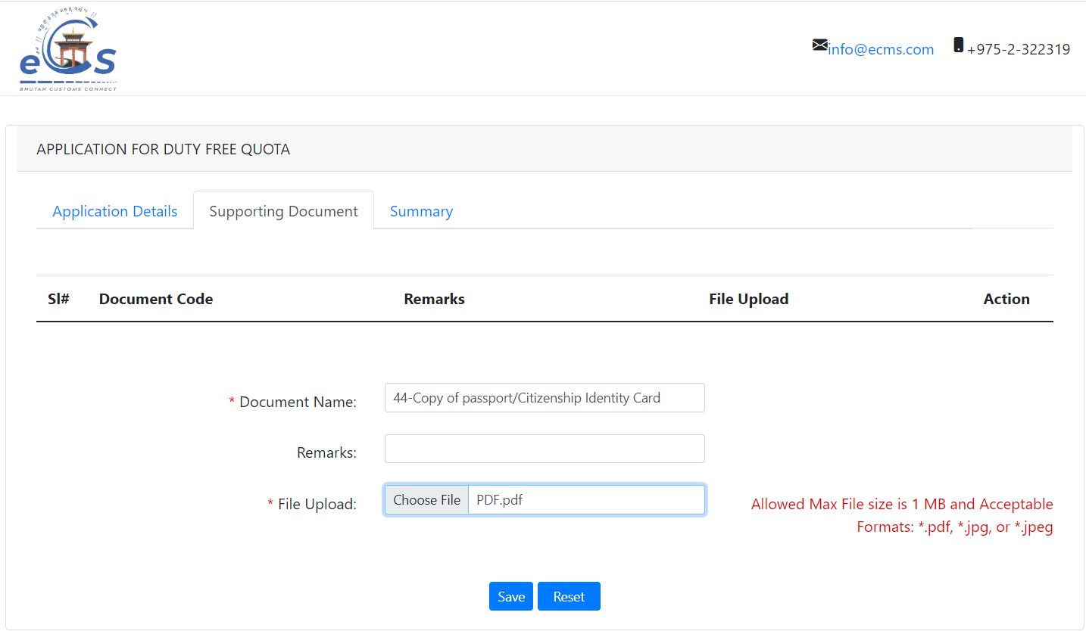

- Mandatory document if any needs to be attached along for the application purpose.

- Summary

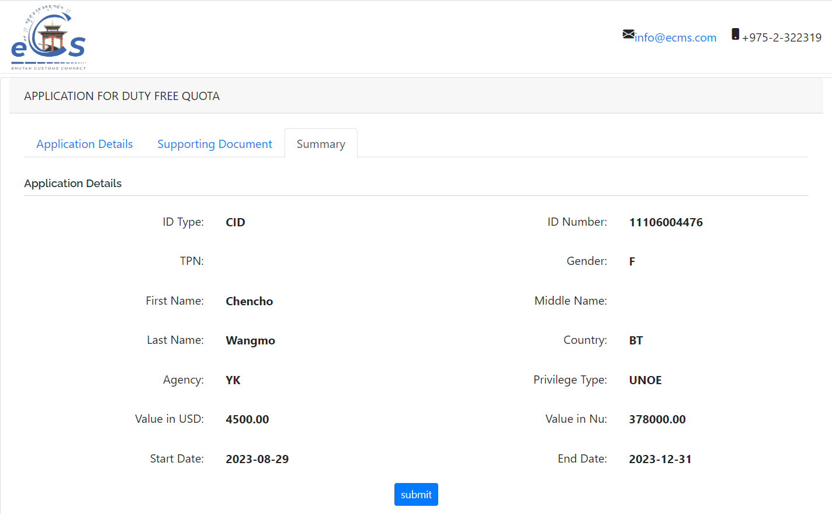
    - The applicant can review his/her application summary and submit the same for approval.
    - Click Submit
    - Reference number is generated, this can be used for tracking application.

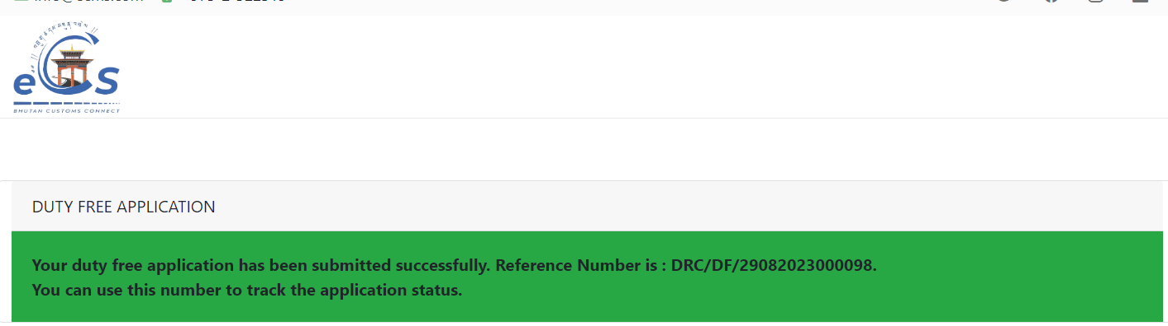
Note: Once approved the applicant will receive mail with their DF Membership letter having approved quota amount

Duty Free Process Flow

Duty-free warehousing declaration.
To have entry of duty free/ airlines warehouse, the user who created the declaration is the warehouse user.

- Login as Warehouse Operator
- Select the menu Declaration FE
- Select Create declaration.

- General Information:

    - Select the Regime: Warehouse>> Select Declaration type as per the requirement and get the details filled and save the data that has been completed.
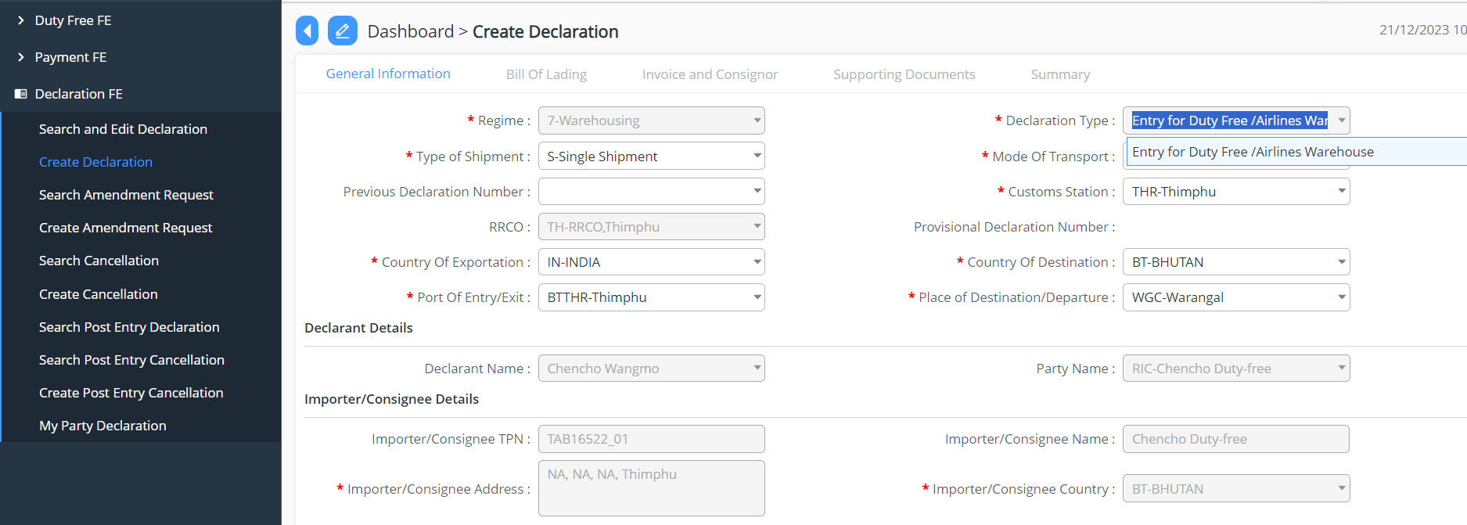
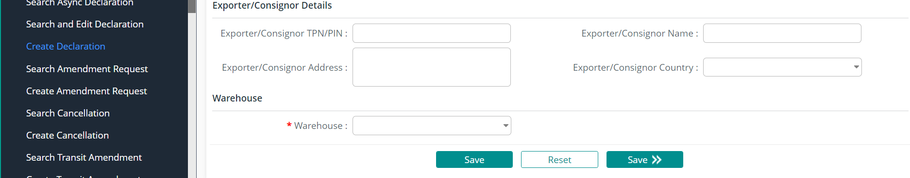

- Bill of Lading

    - The user needs to add in the Bill of landing:
    - Click on tab Bill of Landing
    - Add in by clicking on  button
    - Fill in required details
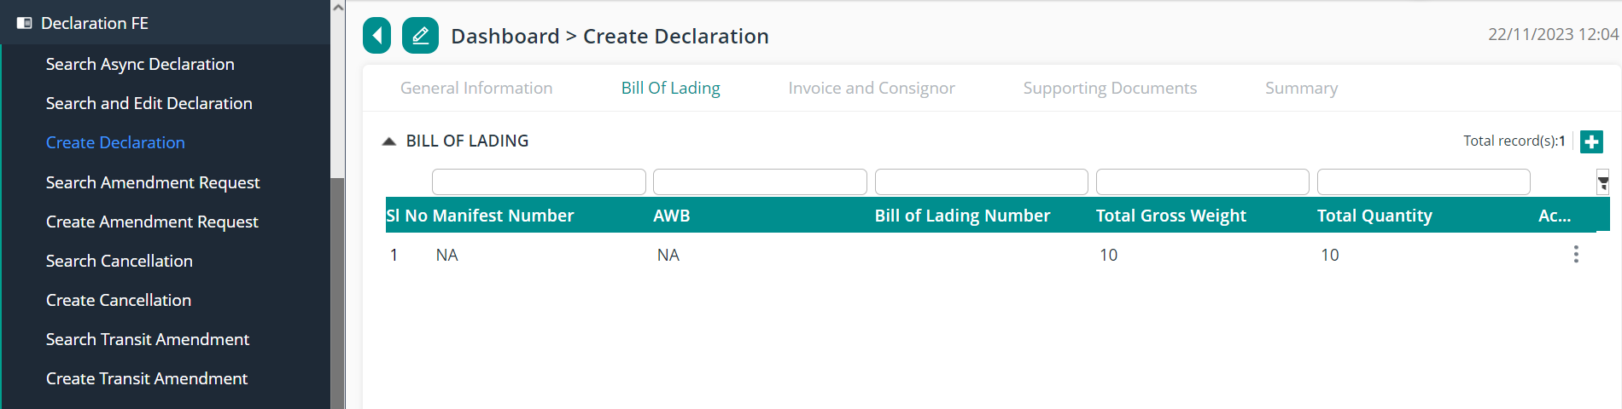
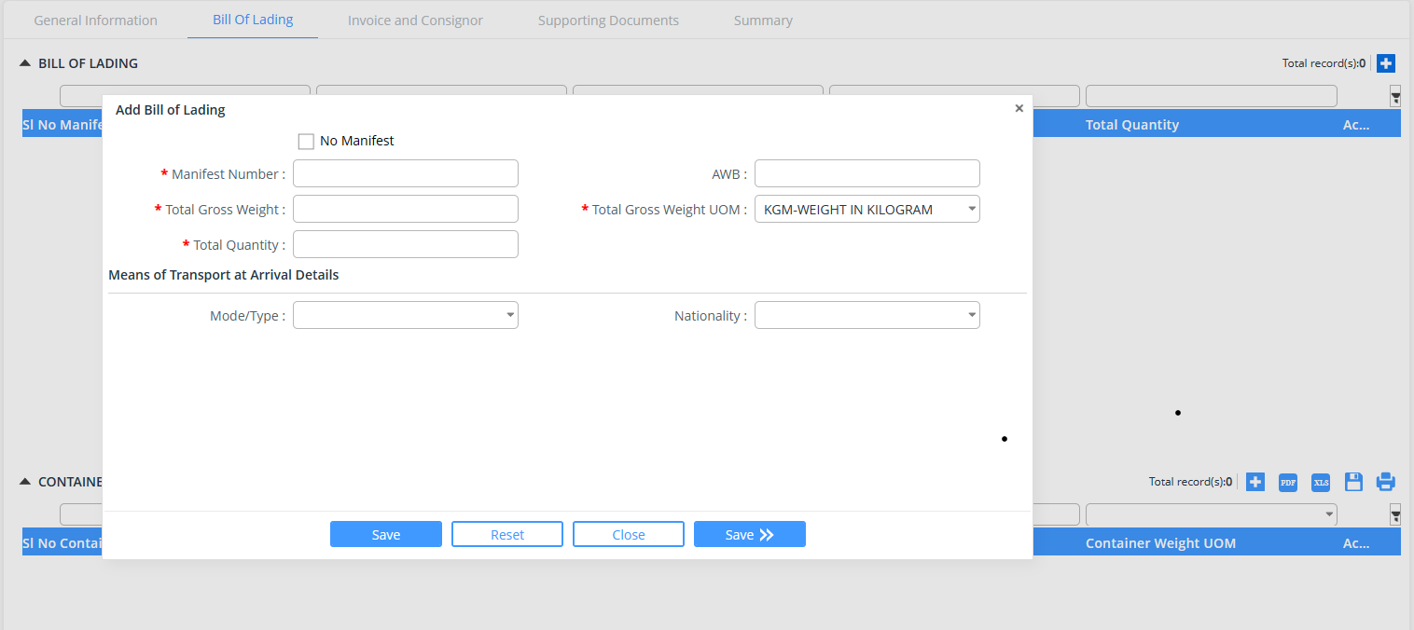
- Invoice and Consignor
    - Add New invoice and consignor details by clicking on 
    - Enter Invoice details first >> Save
    - Enter Commodities details >> Item Details>> Duties and taxes gets auto calculated.
    - Save
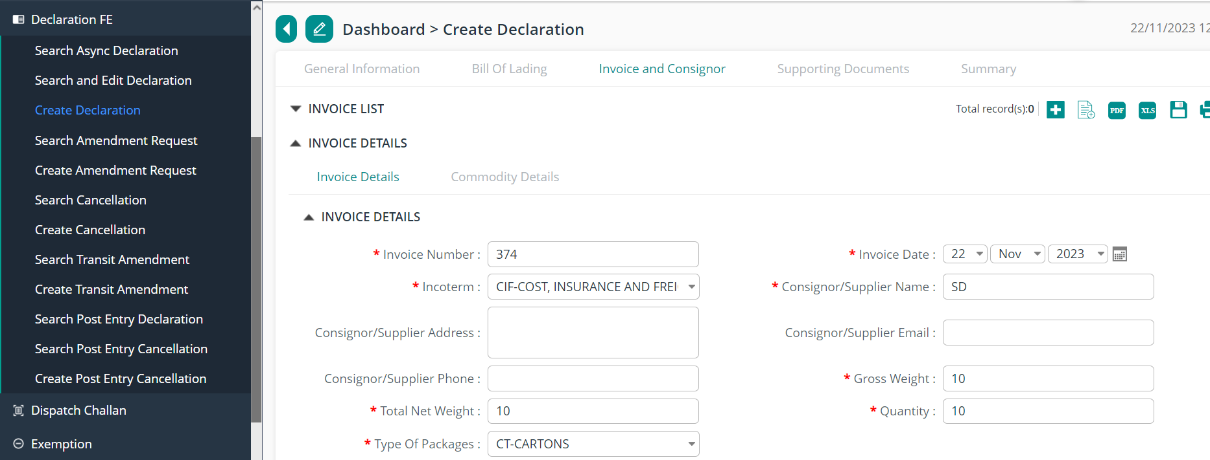
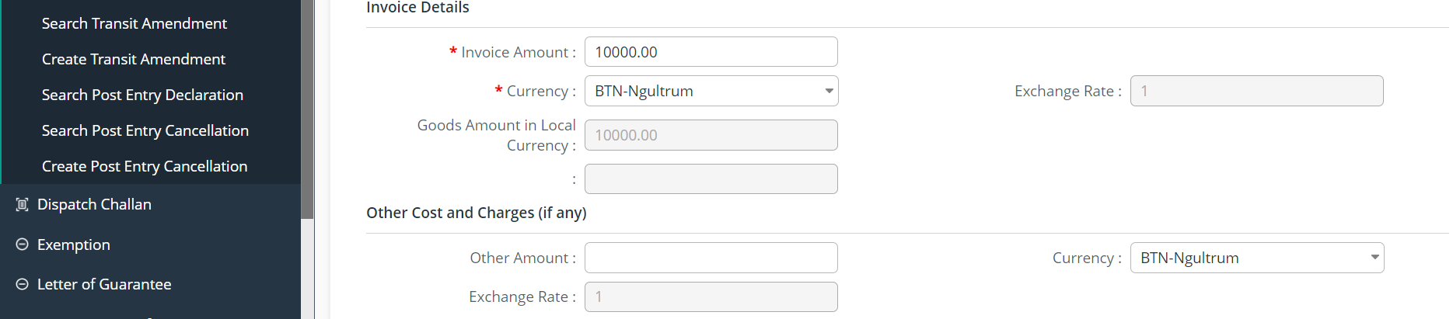
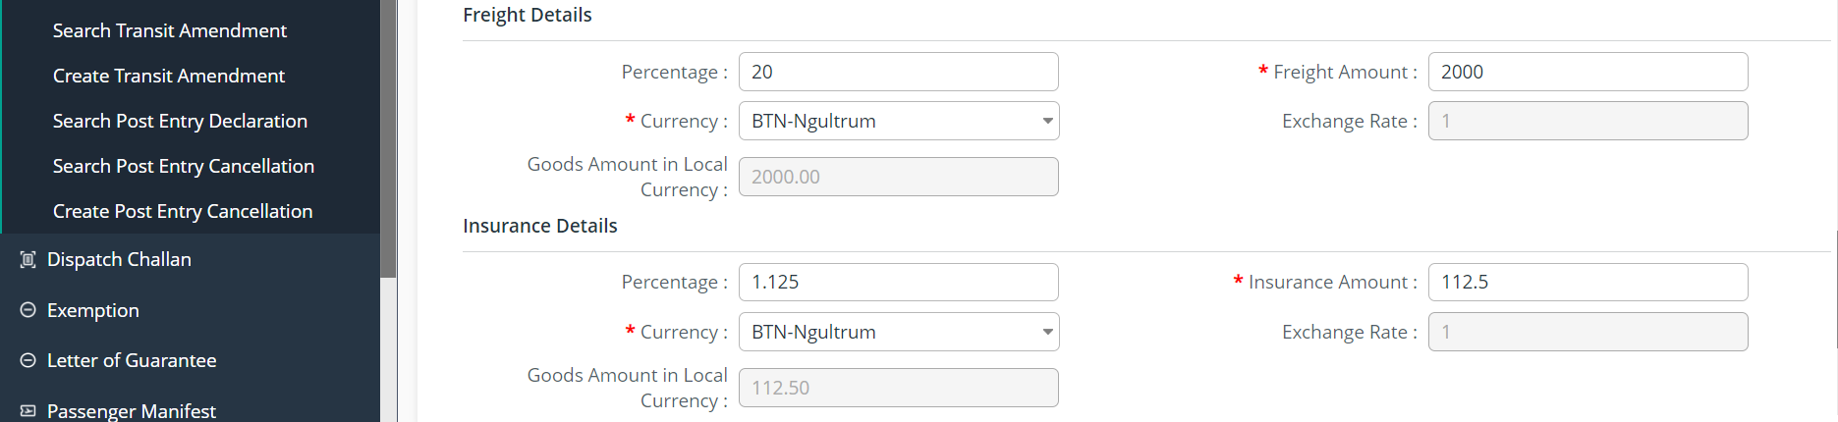
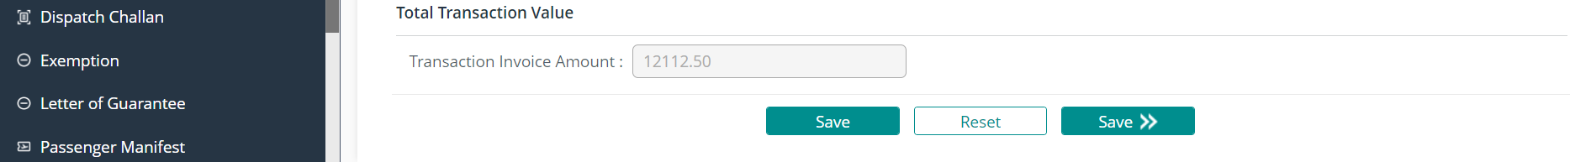
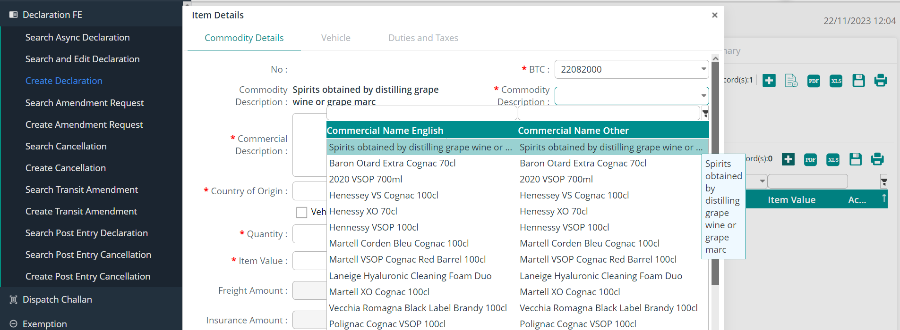
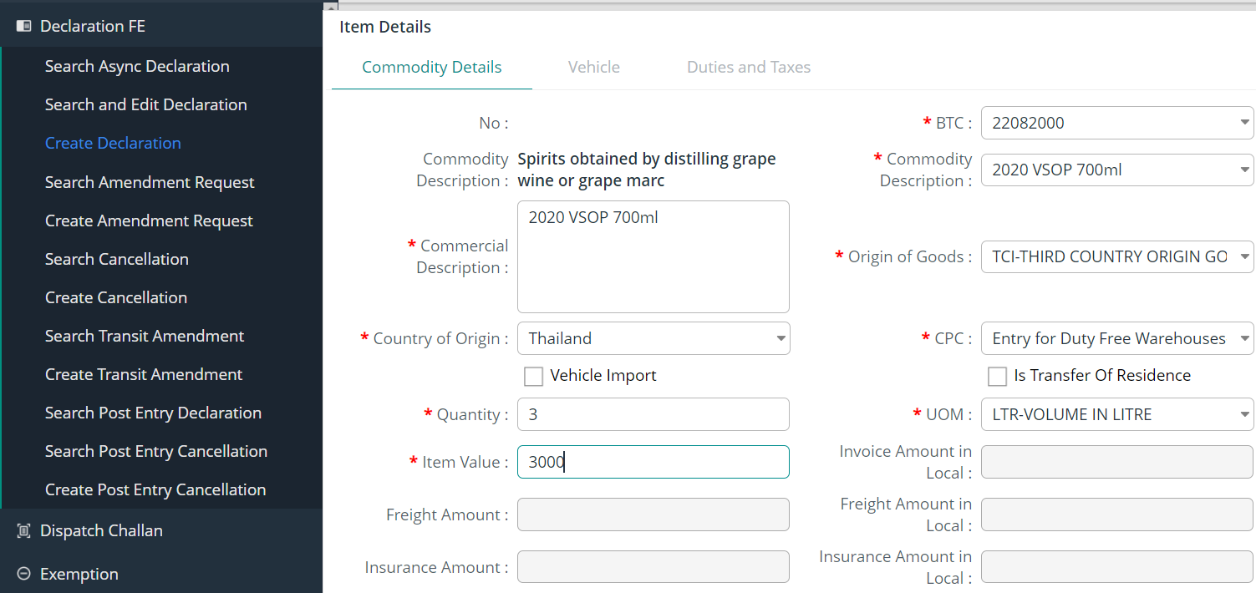
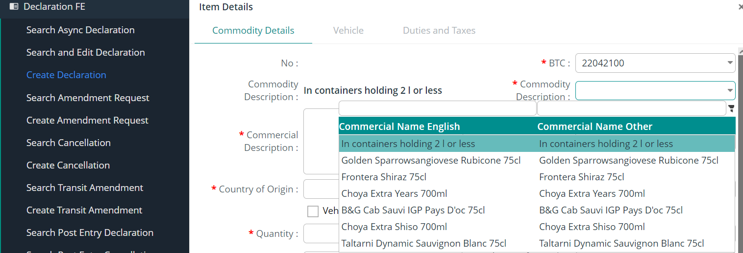
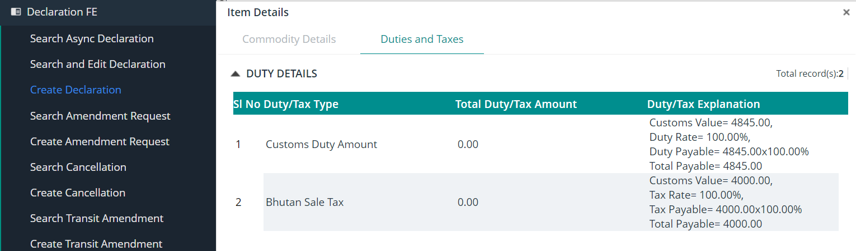

- Supporting Documents

    - The declarant shall attach mandatory supporting documents (invoice) for approval:
    - Click on tab Support Documents
    - Click on Choose File
    - Once document gets uploaded
    - Click on Save

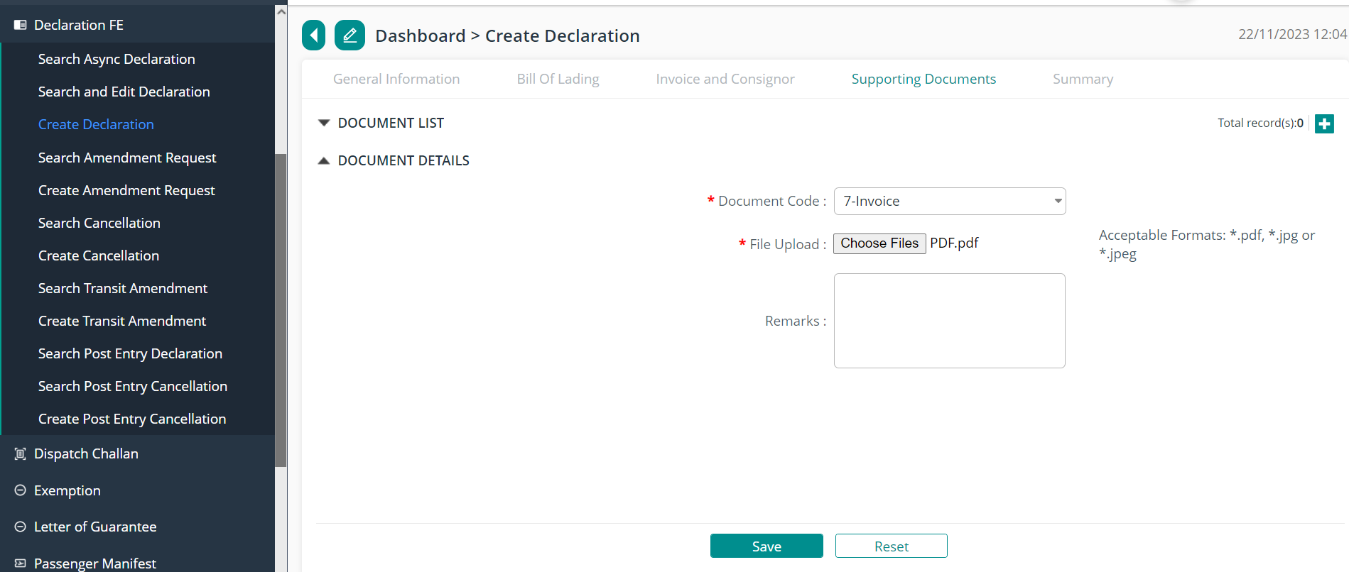

- Summary
    - The declarant can review his/her declaration summary and submit the same for approval, here we have the check box to accept the terms and condition.
    - Here the user can validate the declaration before submission- to do so click on Validate Button.
    - While validation if any data has been mistaken , it will be notified in the red ribbon and if all ok then the dialogue box will appear stating the validation.
    - Click on Validate to validate your entry details.
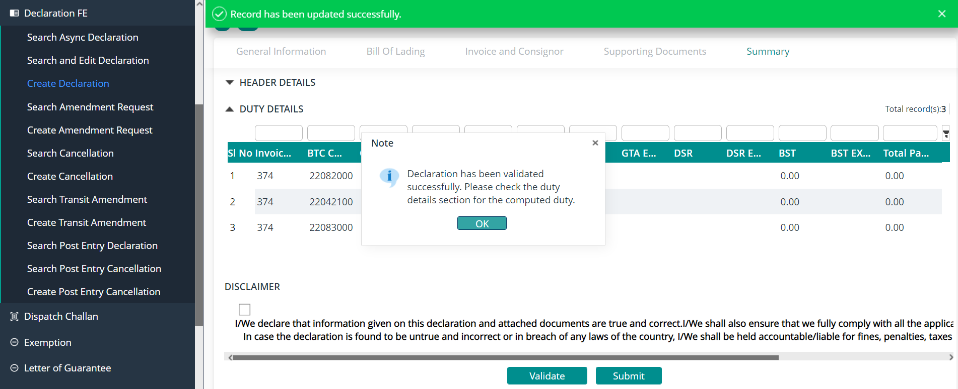
    - The user can submit the declaration which will allow the user to generate the reference declaration number.
    - Once validated , Click on Submit to finally submit your declaration.
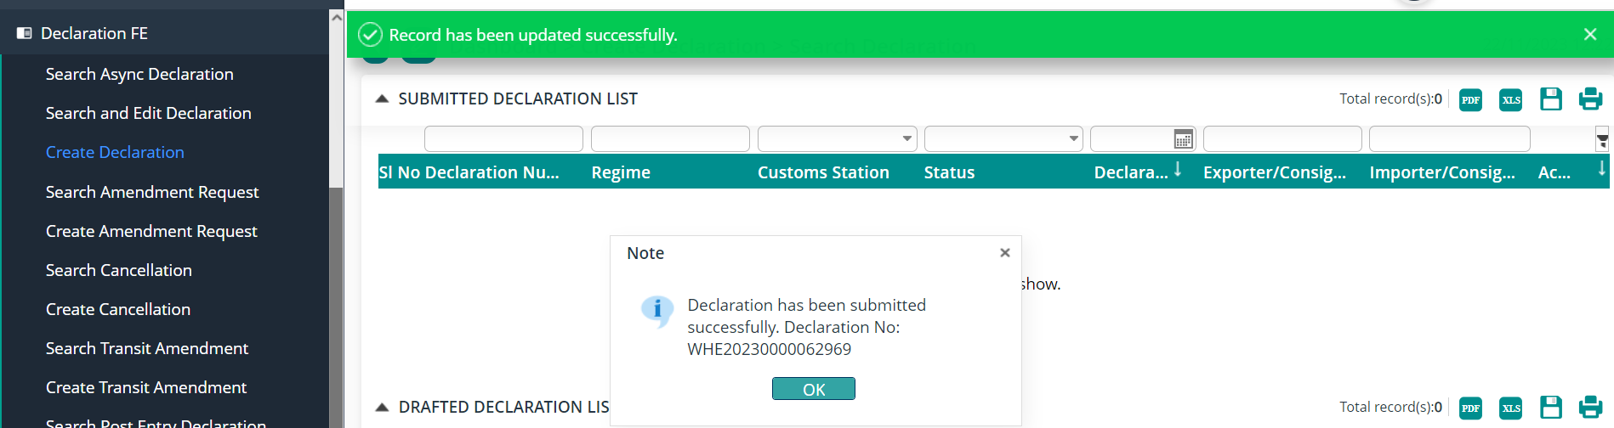

Note: The declaration number generated shall be used to tracking applications

Duty free sales for non-Quota Holder
To create the declaration for the sale of duty free goods to the non- quota holder is as follows:
- Login as Duty Free user
- Select Declaration FE Menu
- Select Create declaration.

- General Information:
    - Select the Regime: Import >> Select Declaration type: Duty Free Sales for non-Quota Holder and get the details filled and save the data that has been completed.

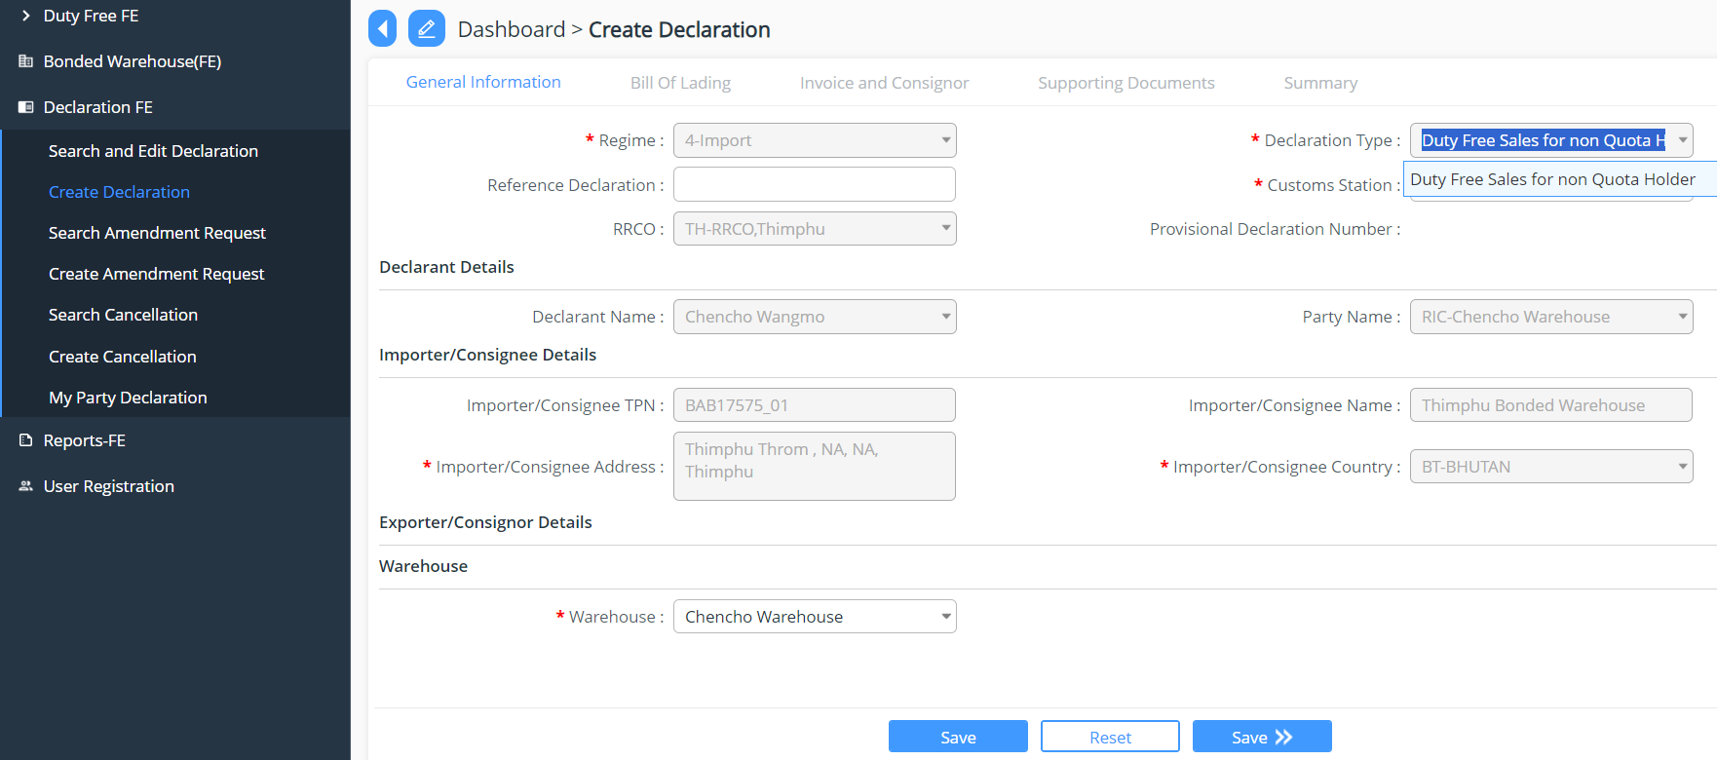

- Invoice and Consignor
    - We can use an excel upload to add in the Invoice and Consigner details
      - Sample Excel for non quota

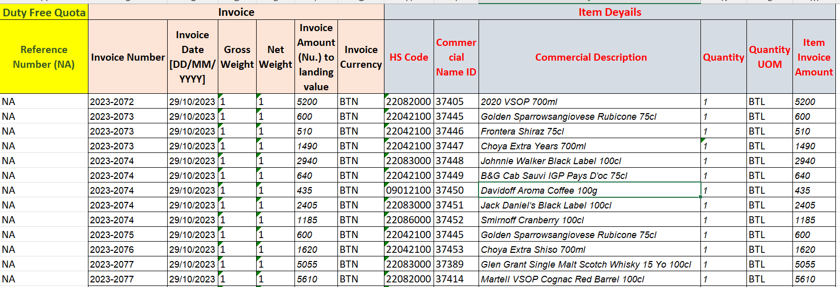

    - Add New invoice and consignor details >> add in the invoice details and commodities details >> Save
    - Here we can upload the excel containing the details , under invoice list and commodity details, all the data will be auto fetched from excel

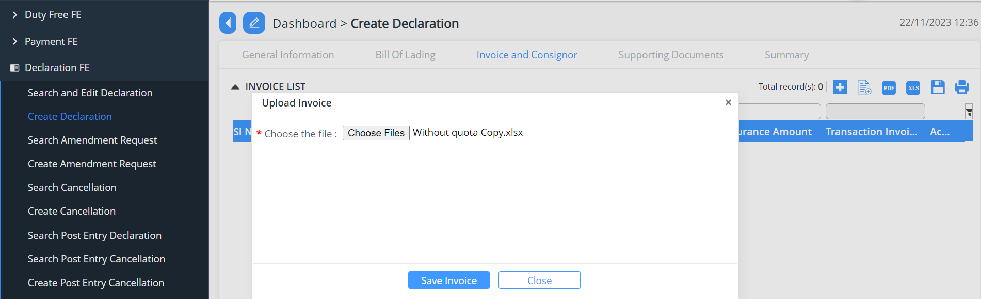
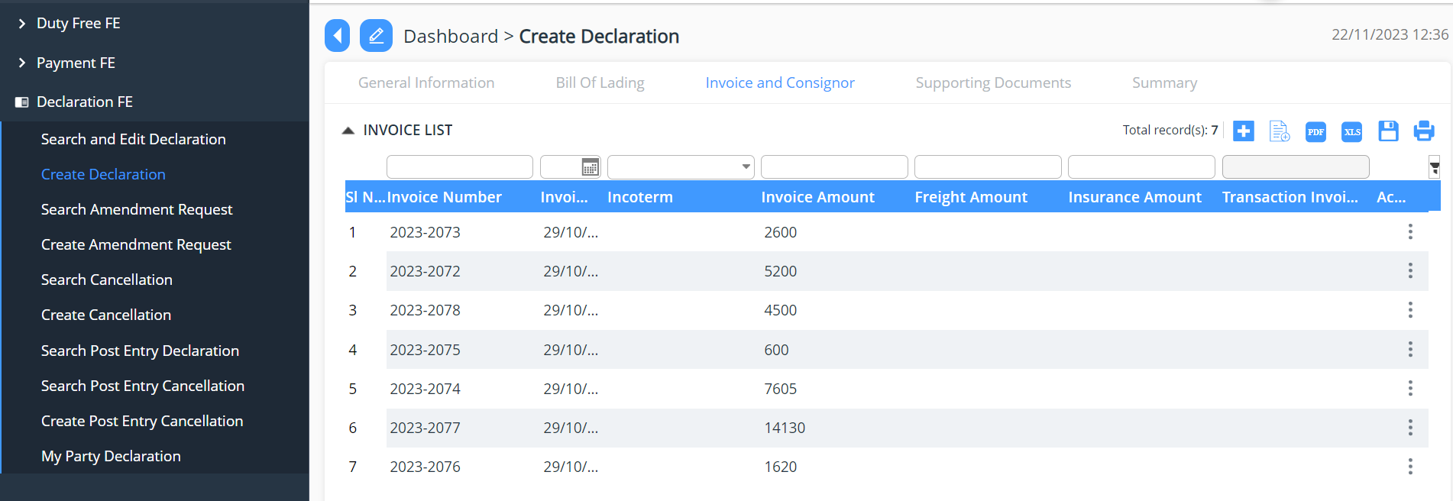
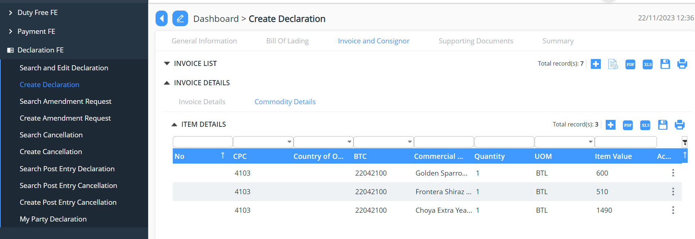

- Supporting document
    - Upload of the mandatory document

- Summary
    - The declarant can review his/her declaration summary and submit the same for approval, here we have the check box to accept the terms and condition.
    - Here the user can validate the declaration before submission- to do so click on Validate Button.
    - While validation if any data has been mistaken, it will be notified in the red ribbon and if all ok then the dialogue box will appear stating the validation.

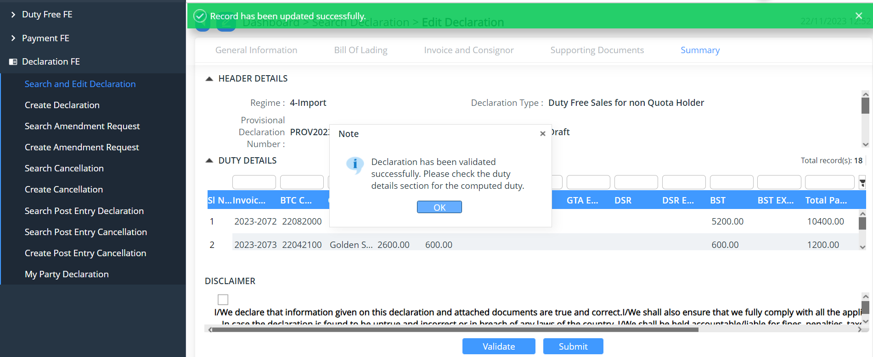

    - The user can submit the declaration which will allow the user to generate the reference declaration number.

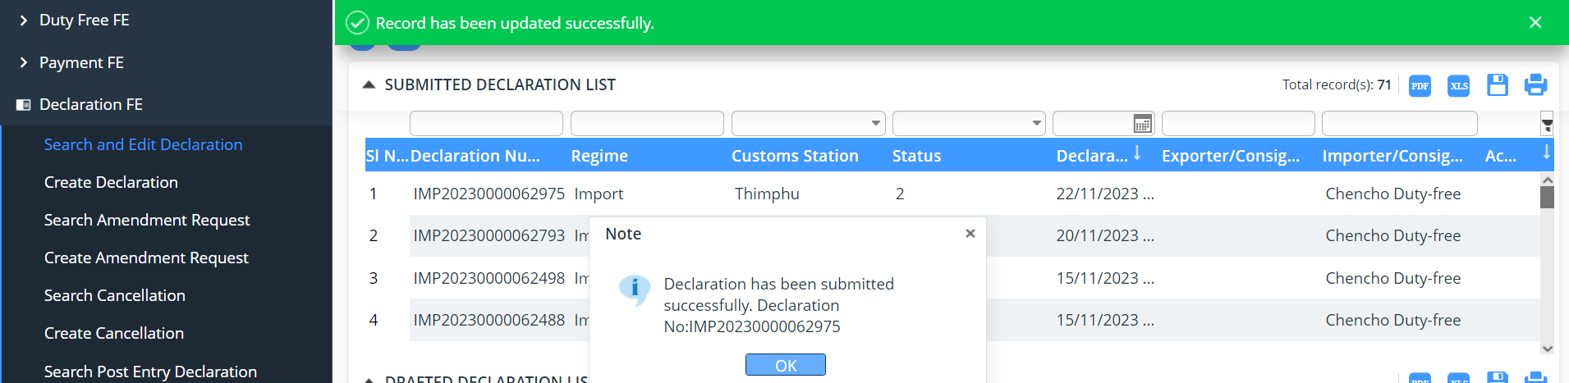

Note: The declaration number generated shall be used to tracking applications

Duty-free Sales for Quota Holder
To create the declaration for the sale of duty-free goods to the quota holder is as follows:

- Login as Duty Free user
- Select Declaration FE Menu
- Select Create declaration.

- General Information:
    - Select the Regime: Import >> Select Declaration type: Duty Free Sales for Quota Holder and get the details filled and save the data that has been completed.
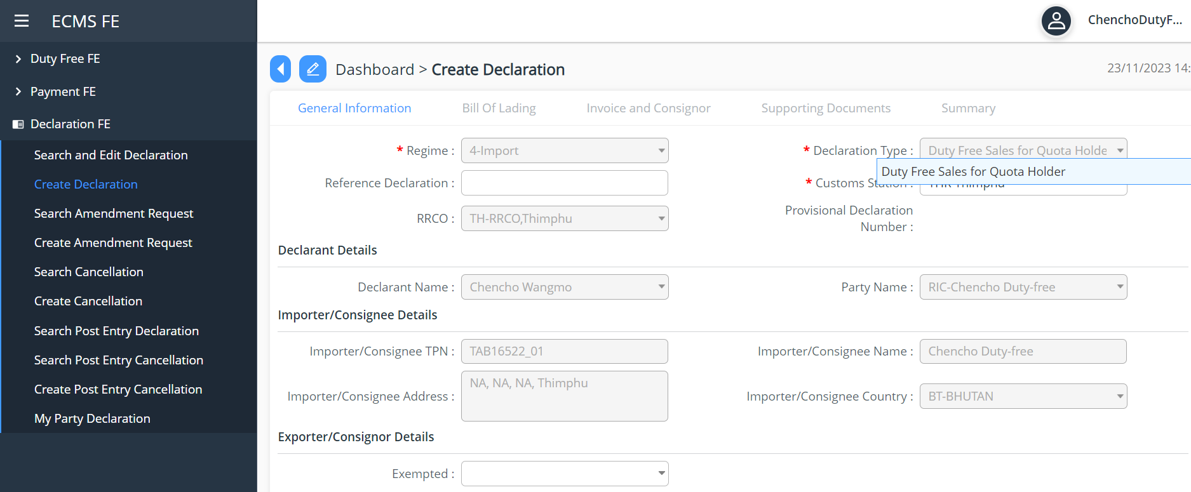
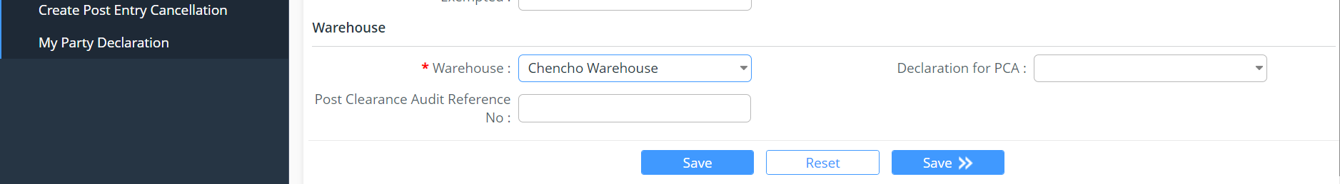

- Invoice and Consignor
    - We can use an excel upload to add in the Invoice and Consigner details
      - Sample Excel for non quota
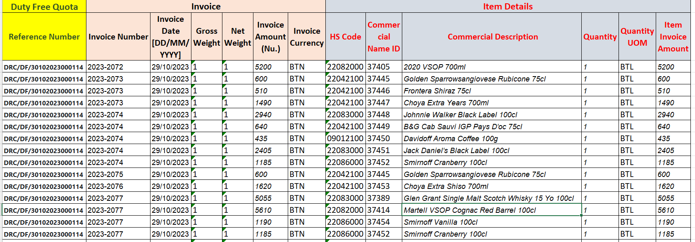

    - Add New invoice and consignor details >> add in the invoice details and commodities details >> Save
    - Here we can upload the excel containing the details , under invoice list and commodity details, all the data will be auto fetched from excel

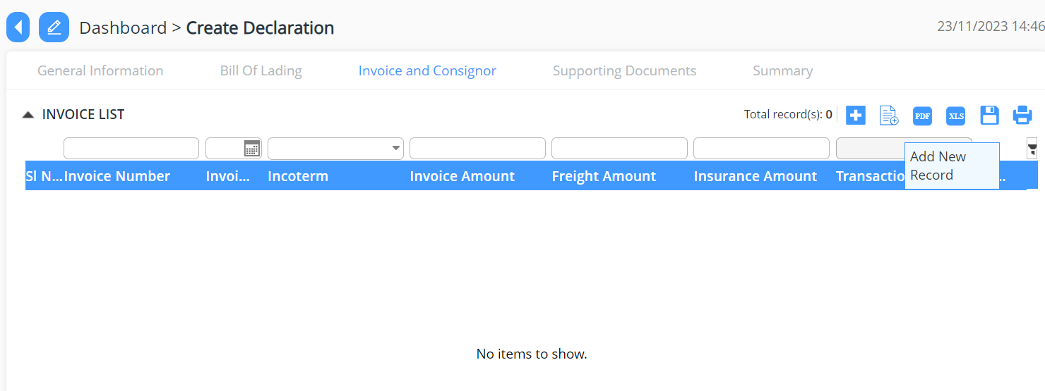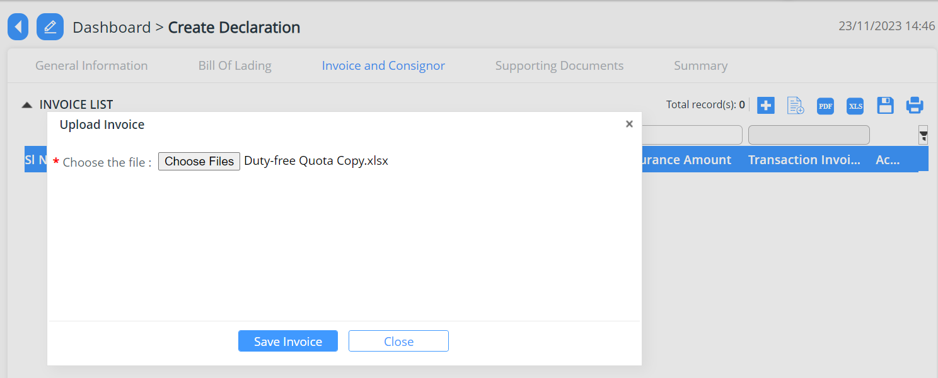
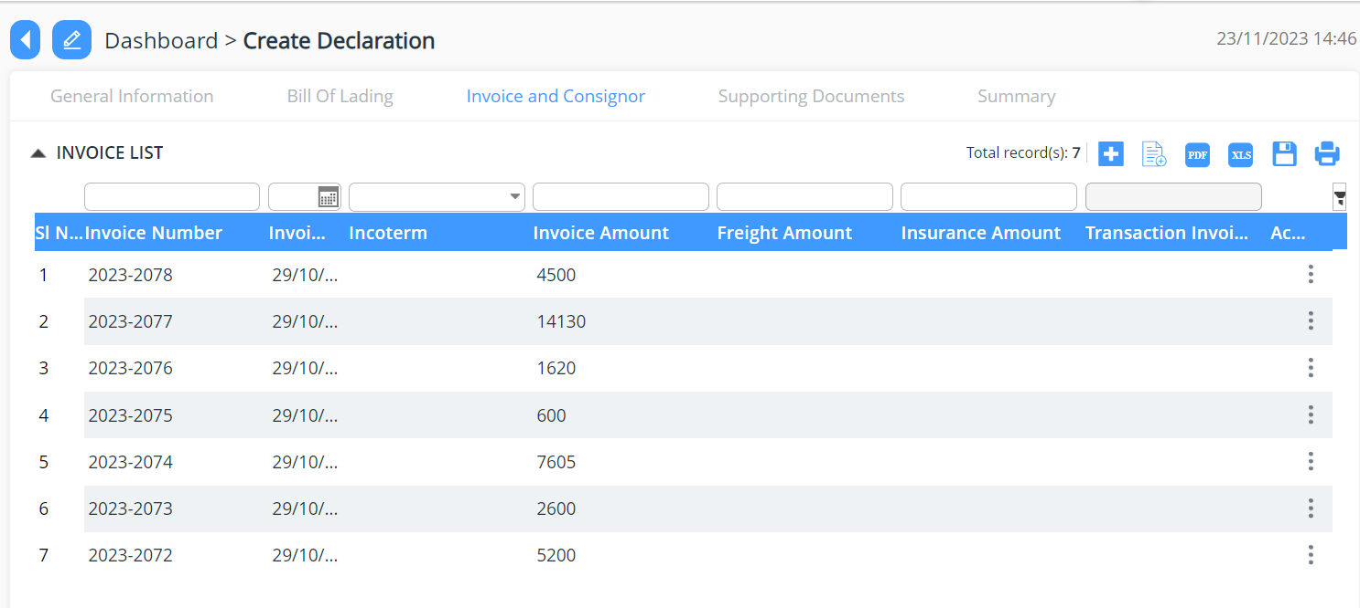
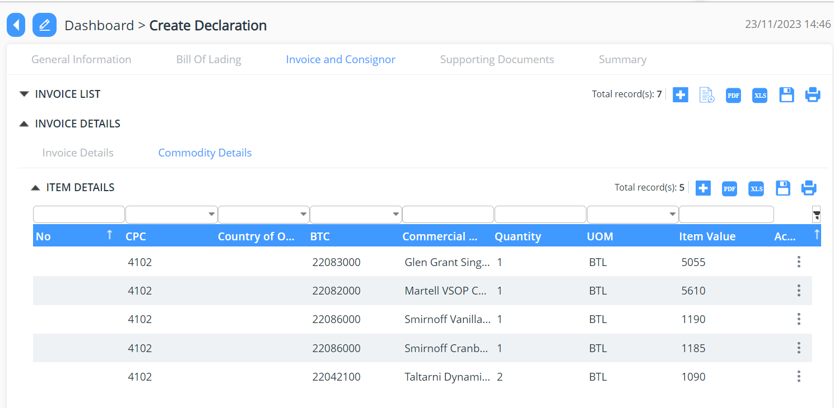
- Supporting Documents
    - The declarant shall attach mandatory supporting documents (invoice) for approval.

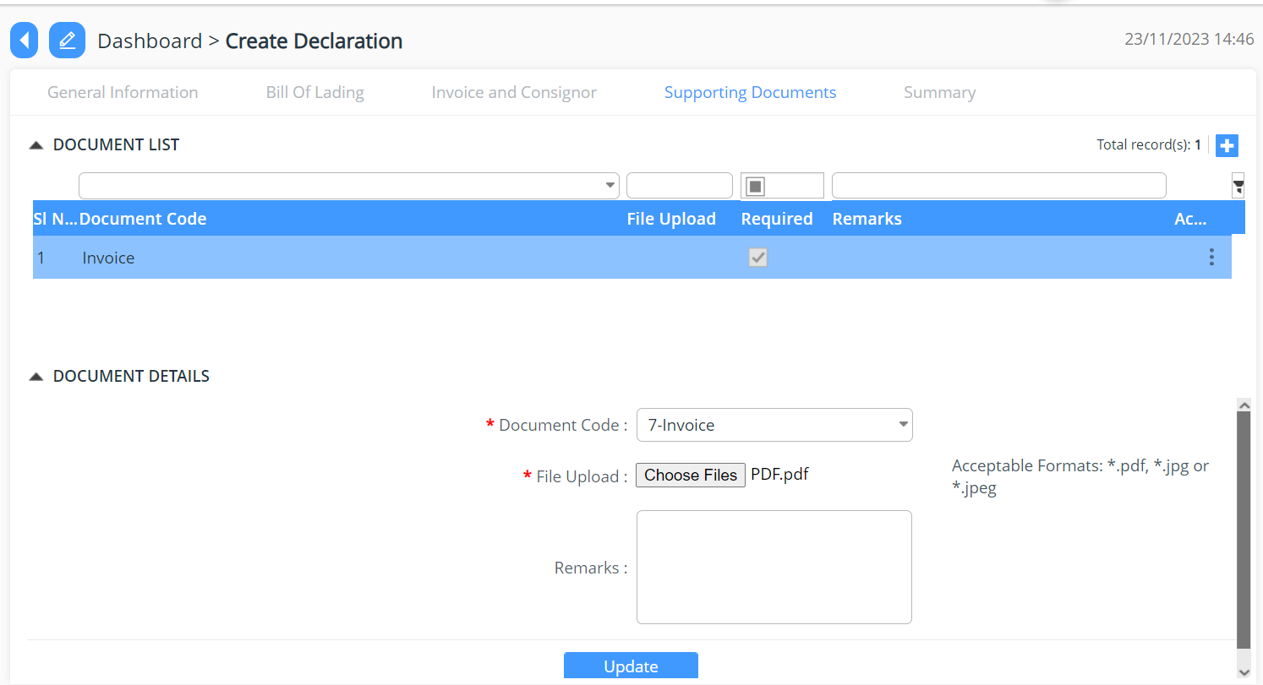

- Summary
    - The declarant can review his/her declaration summary and submit the same for approval, here we have the check box to accept the terms and condition.
    - Here the user can validate the declaration before submission- to do so click on Validate Button.
    - While validation if any data has been mistaken, it will be notified in the red ribbon and if all ok then the dialogue box will appear stating the validation

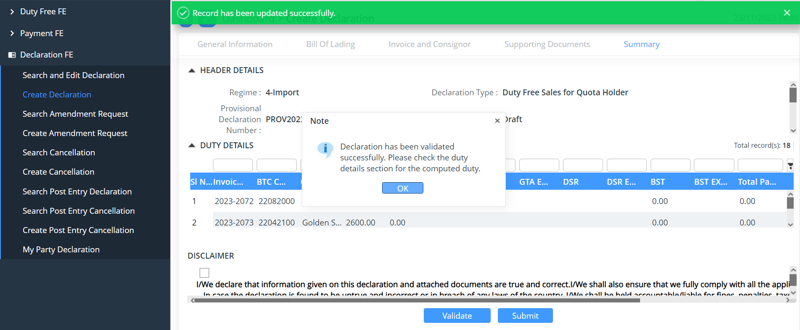

    - The user can submit the declaration which will allow the user to generate the reference declaration number.

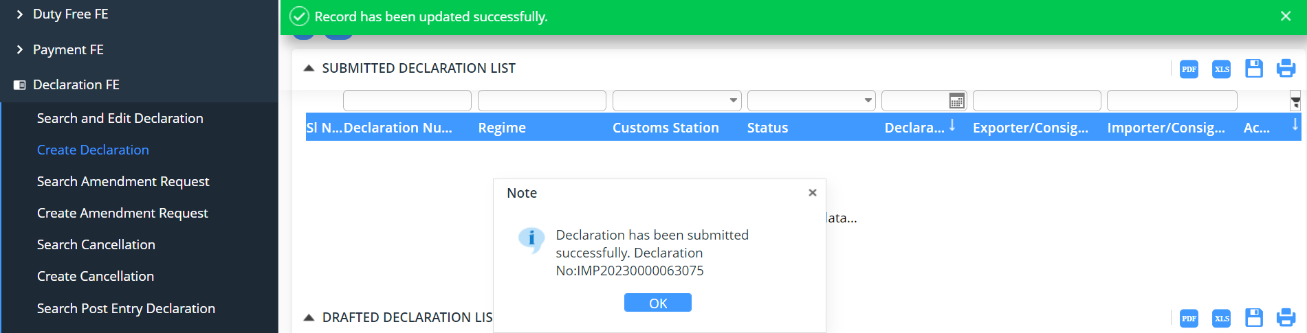

Note: The declaration number generated shall be used to tracking applications

Duty Free Sales at Airport
Duty-free sale at airport, the declaration created should be link with flight date, passport number, flight number and bound type.

- Login as Duty Free user
- Select Declaration FE Menu
- Select Create declaration.

- General Information

    - Select the Regime: Import >> Select Declaration type: Duty Free Sales from Airport and get the details filled and save the data that has been completed

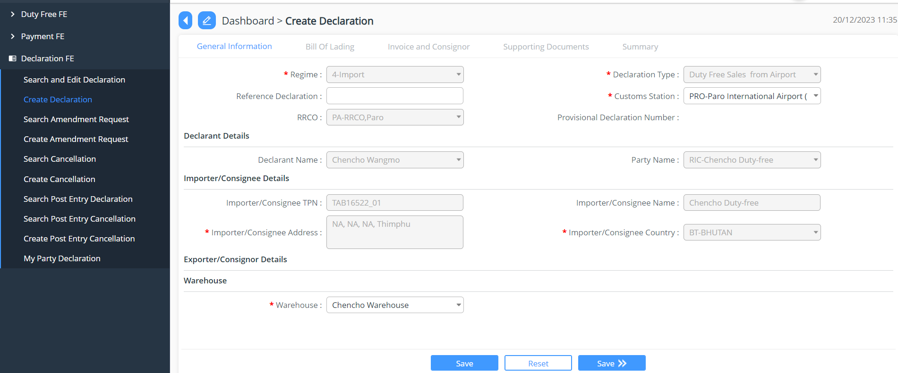

- Invoice and Consignor

    - We can use an excel upload to add in the Invoice and Consigner details
    - Sample Excel for non-quota

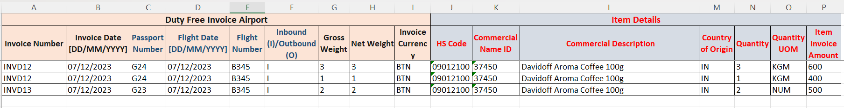

    - Add New invoice and consignor details >> add in the invoice details and commodities details >> Save
    - Here we can upload the excel containing the details , under invoice list and commodity details, all the data will be auto fetched from excel

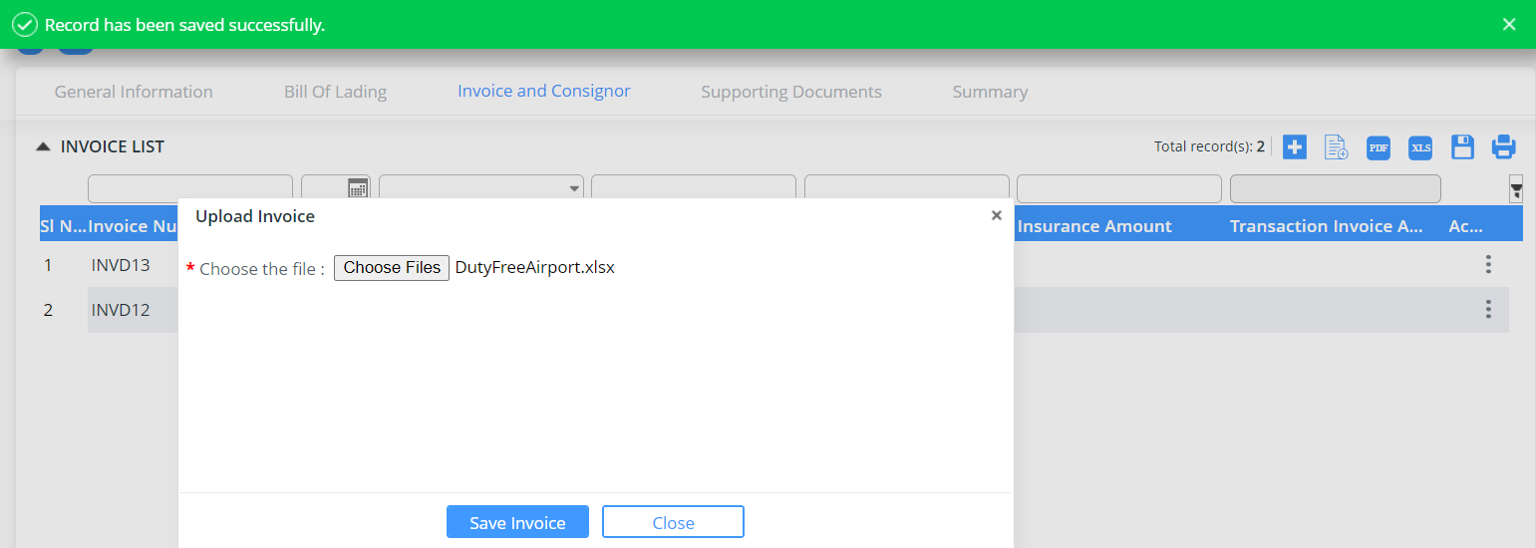

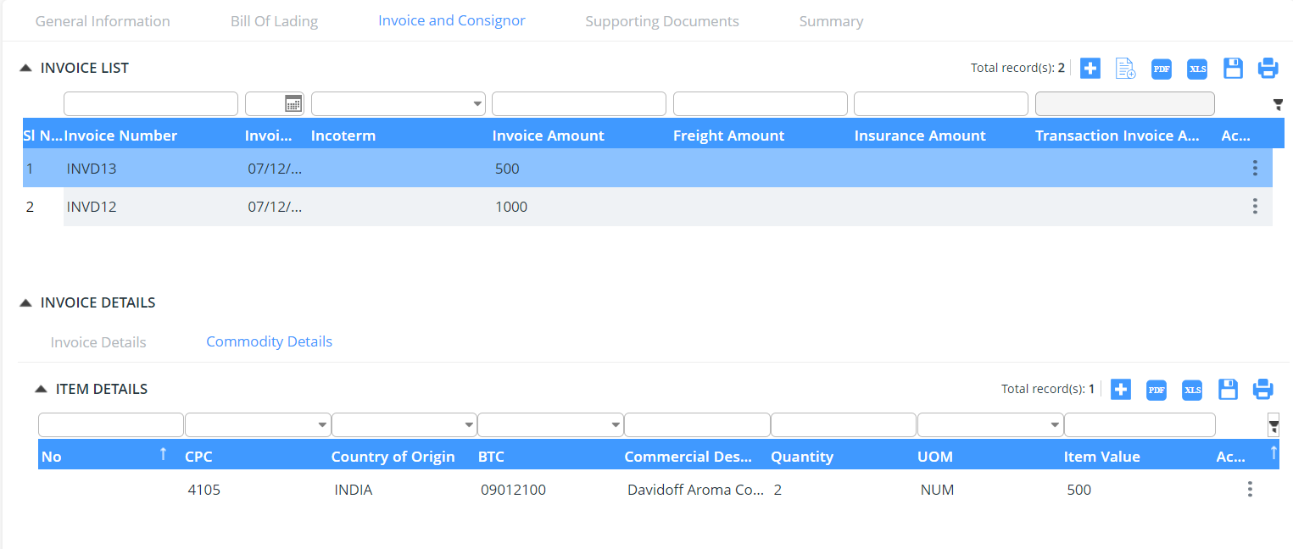
- Supporting document
    - Upload of the mandatory document

- Summary
    - The declarant can review his/her declaration summary and submit the same for approval, here we have the check box to accept the terms and condition.
    - Here the user can validate the declaration before submission- to do so click on Validate Button.
    - While validation if any data has been mistaken, it will be notified in the red ribbon and if all ok then the dialogue box will appear stating the validation

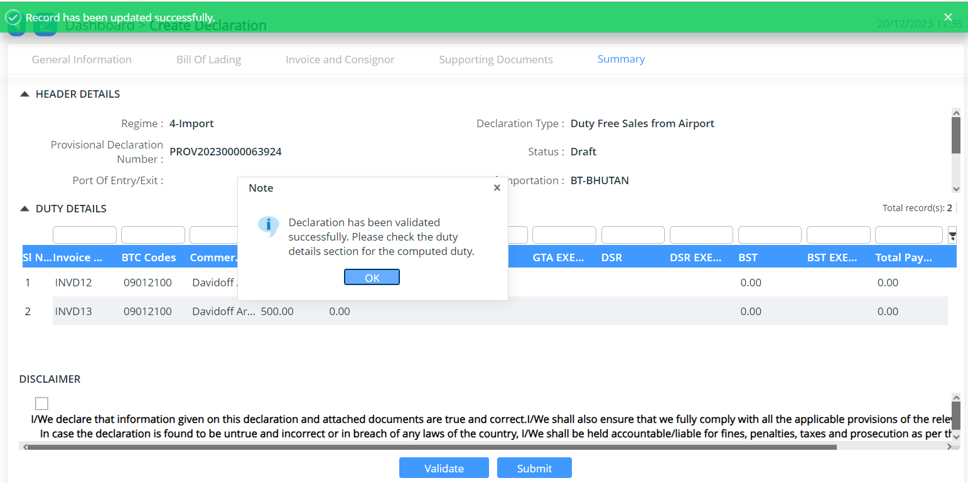

    - The user can submit the declaration which will allow the user to generate the reference declaration number.

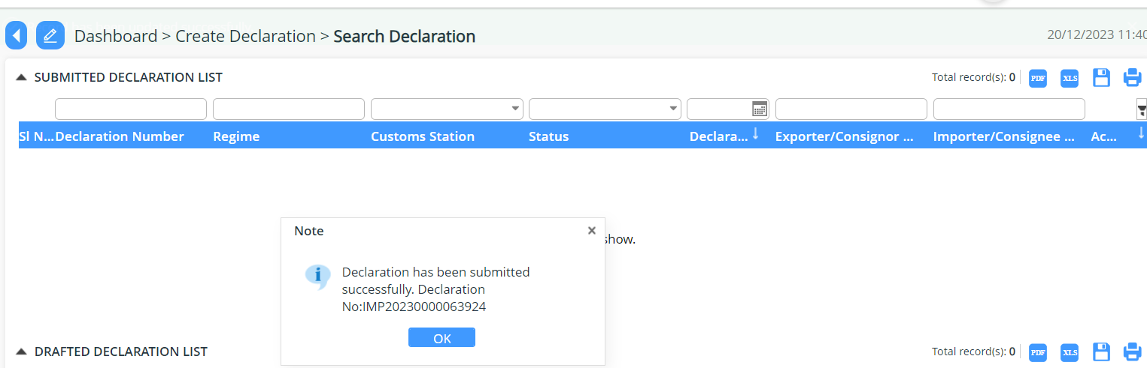

Note: The declaration number generated shall be used to tracking applications

Duty Free Consumption on Board
Duty-free consumption and sales on board, the declaration created should be validated with flight date, flight number and bound type.

- Login as Airlines user
- Select Declaration FE Menu
- Select Create declaration.

- General Information:
    - Select the Regime: Import >> Select Declaration type: Duty Free Airlines for Consumption/Stores and get the details filled and save the data that has been completed.

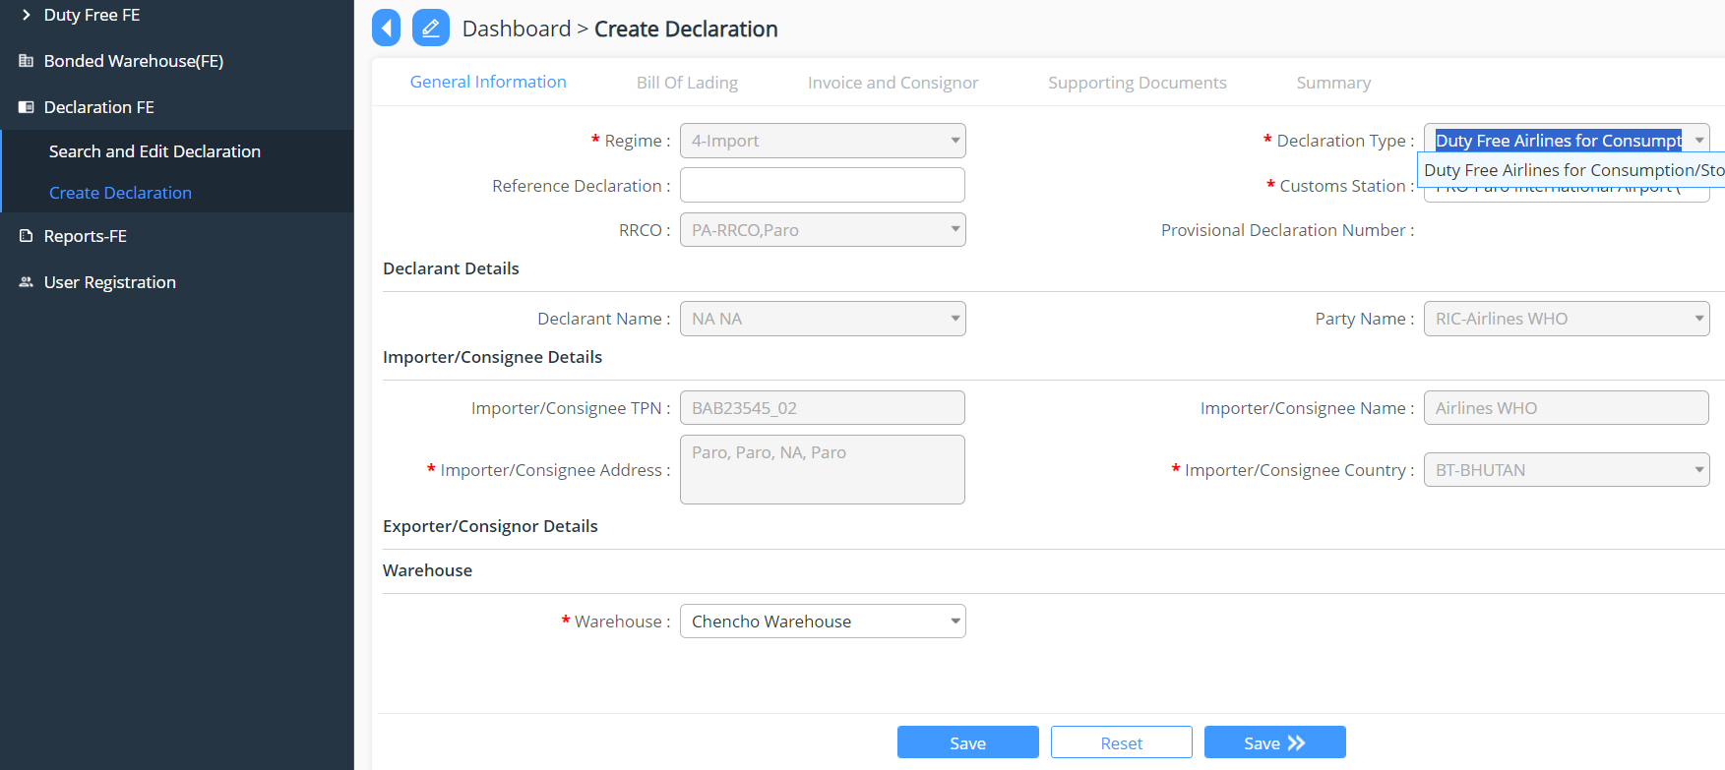

- Invoice and Consignor

    - We can use an excel upload to add in the Invoice and Consigner details
    - Sample Excel for non quota

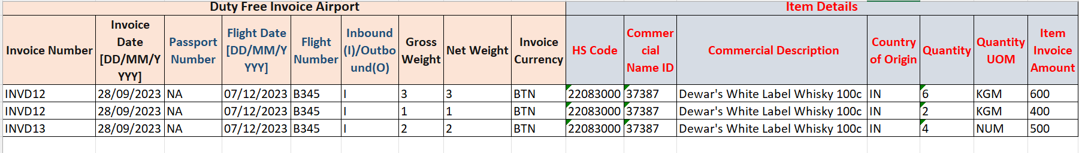
    - Add New invoice and consignor details >> add in the invoice details and commodities details >> Save
    - Here we can upload the excel containing the details , under invoice list and commodity details, all the data will be auto fetched from excel

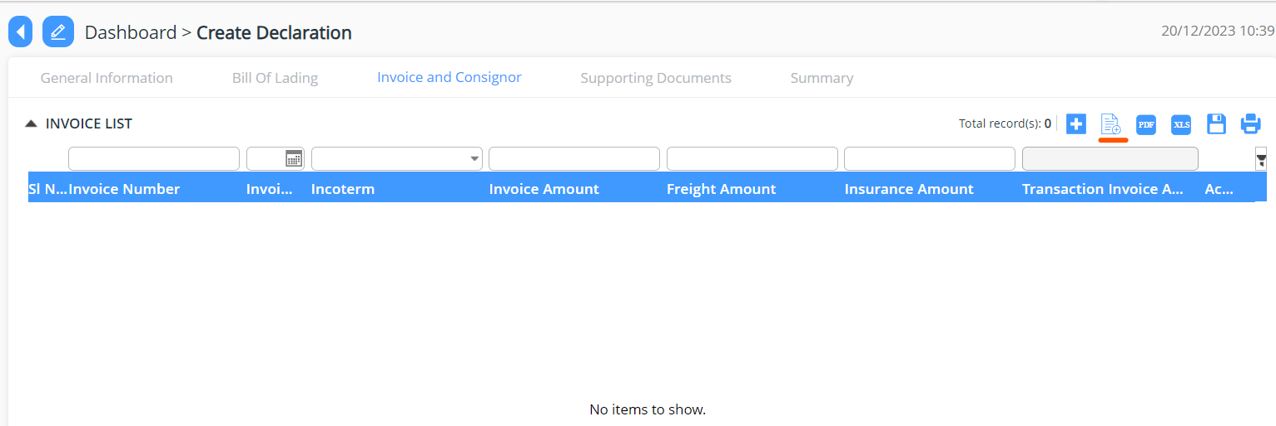
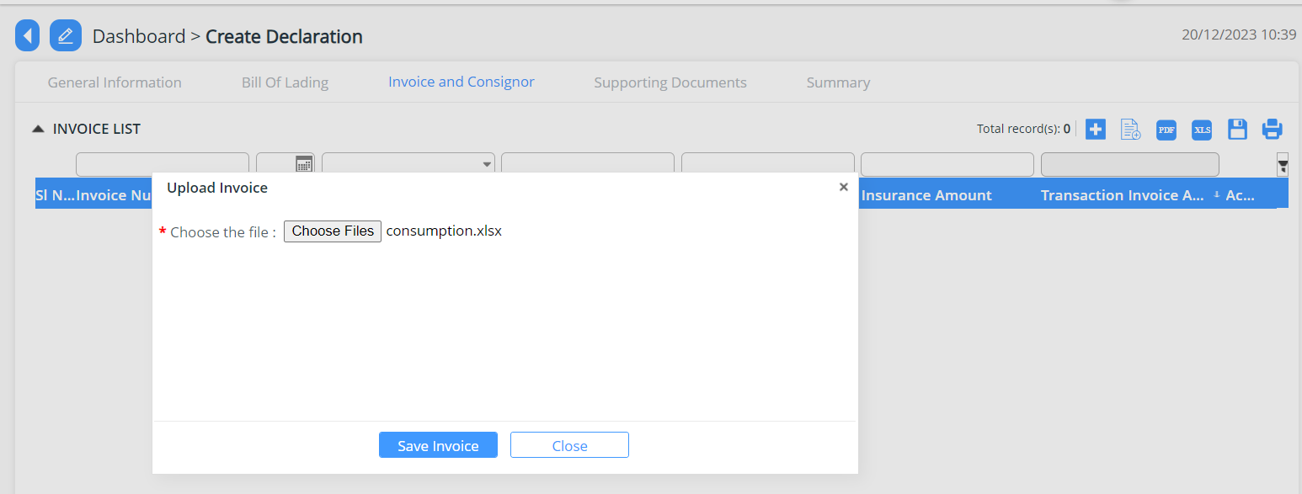

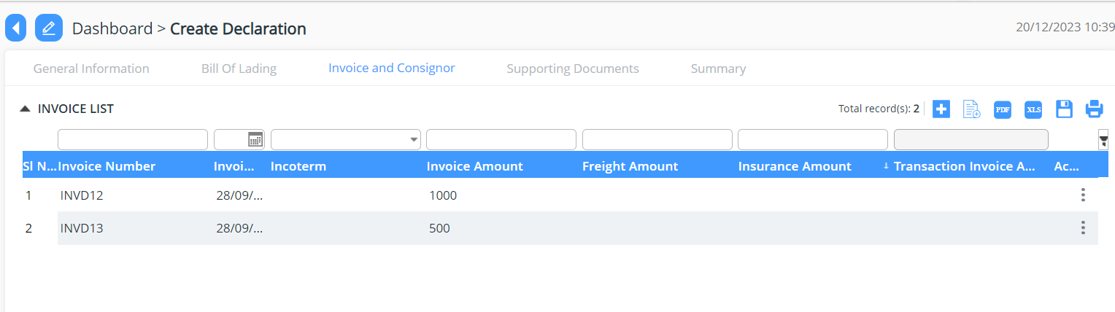
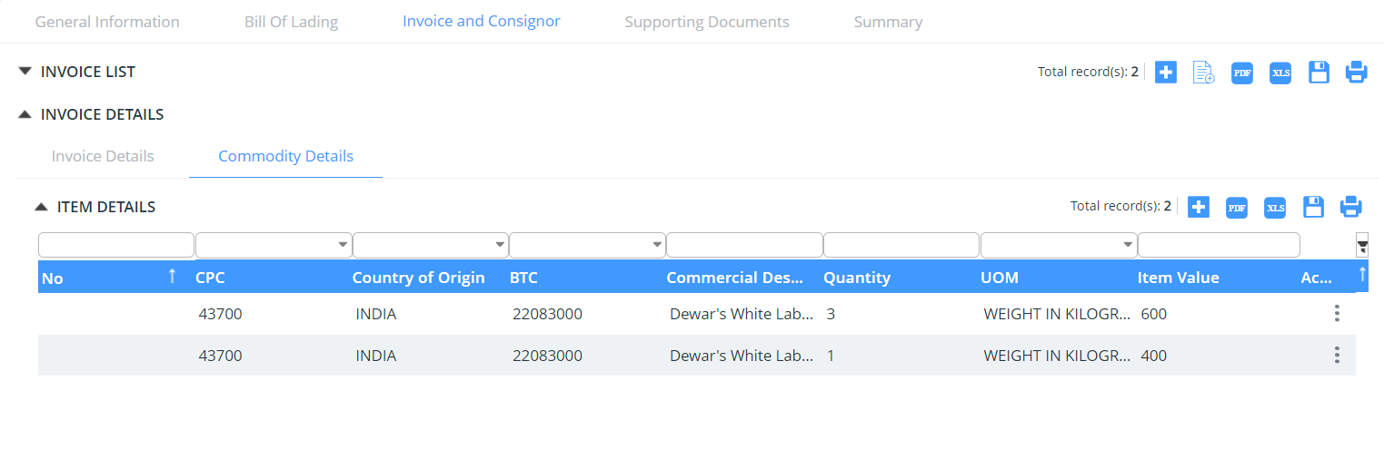
- Supporting document
    - Upload of the mandatory document
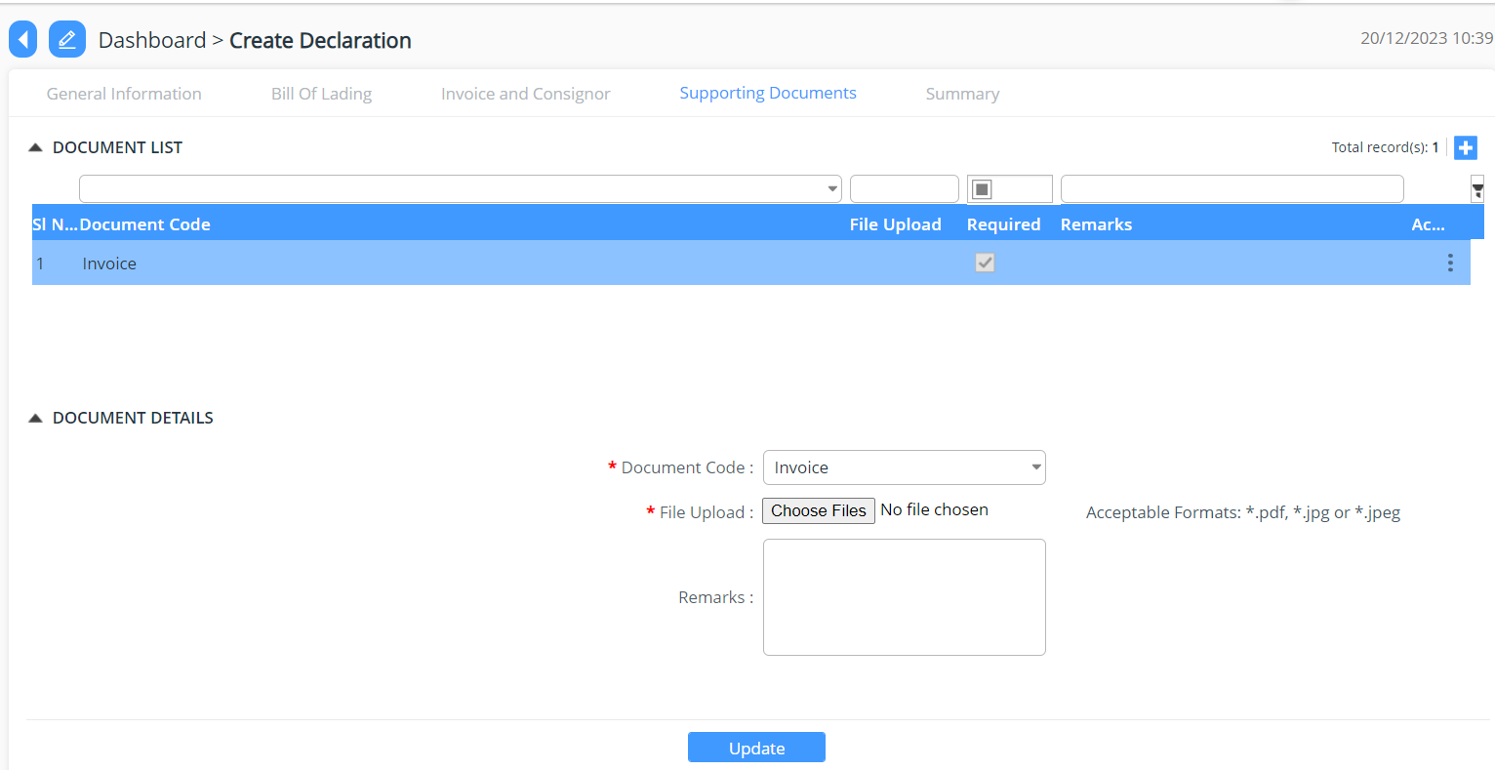

- Summary
    - The declarant can review his/her declaration summary and submit the same for approval, here we have the check box to accept the terms and condition.
    - Here the user can validate the declaration before submission- to do so click on Validate Button.
    - While validation if any data has been mistaken, it will be notified in the red ribbon and if all ok then the dialogue box will appear stating the validation

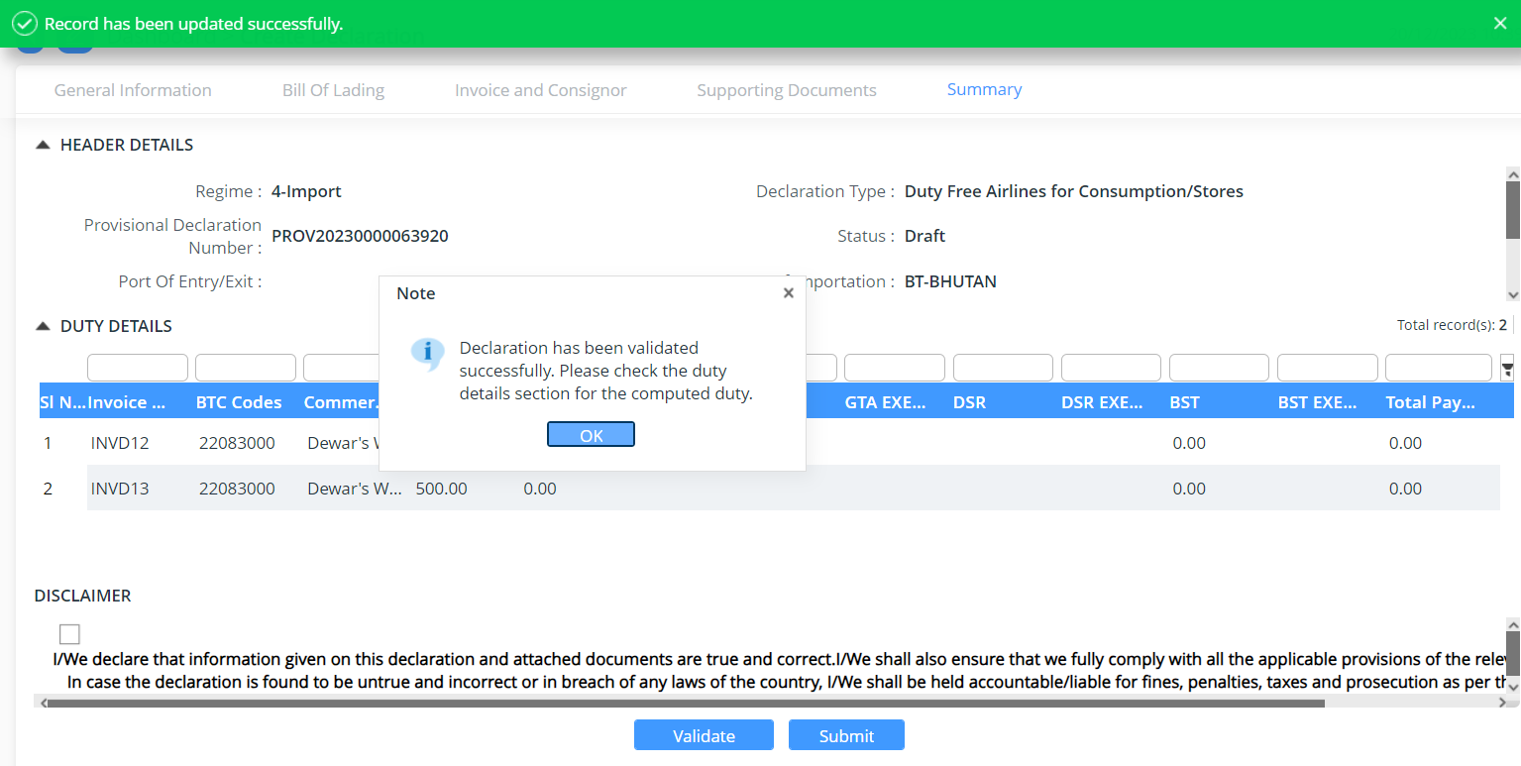

    - The user can submit the declaration which will allow the user to generate the reference declaration number.

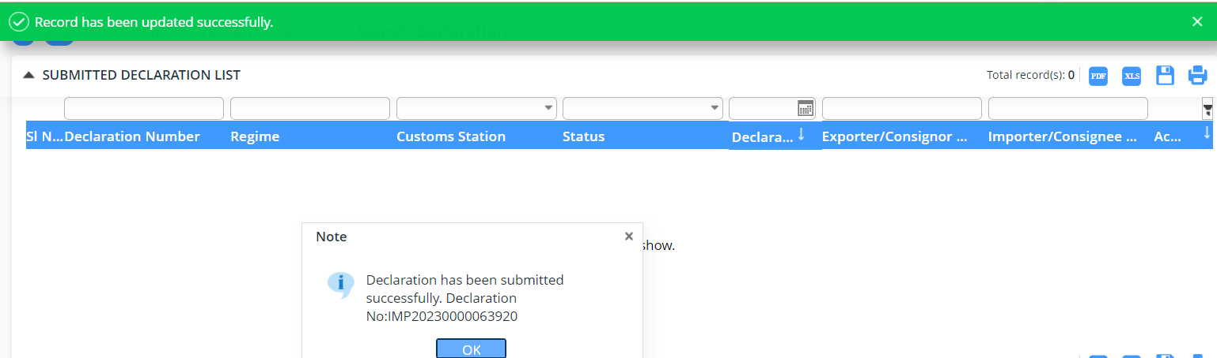

Note: The declaration number generated shall be used to tracking applications

Duty Free Sales on Board
Duty-free consumption and sales on board, the declaration created should be validated with passport number, flight date, flight number and bound type.

- Login as Airlines user
- Select Declaration FE Menu
- Select Create declaration.

- General Information:
    - Select the Regime: Import >> Select Declaration type: Duty Free Airlines for Sales on Board and get the details filled and save the data that has been completed.

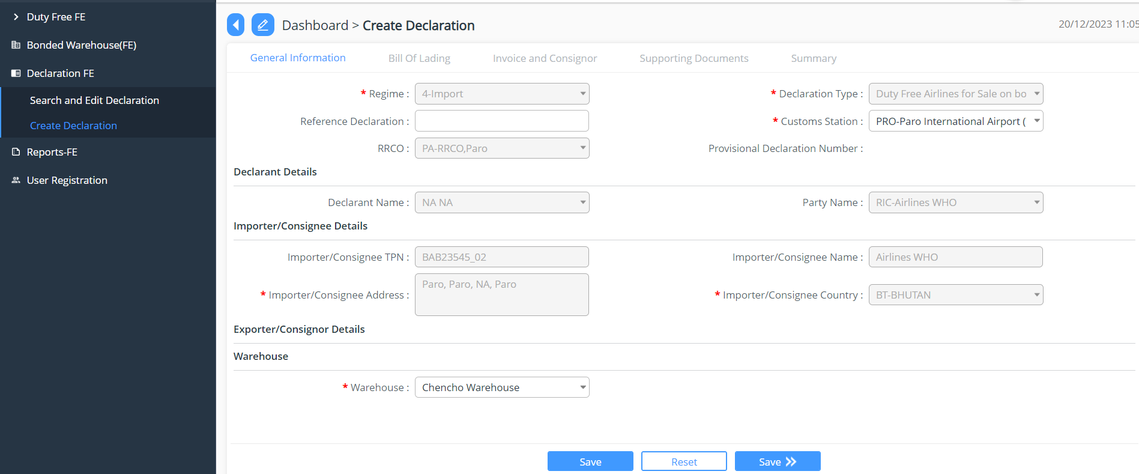

- Invoice and Consignor

    - We can use an excel upload to add in the Invoice and Consigner details
    - Sample Excel for non quota

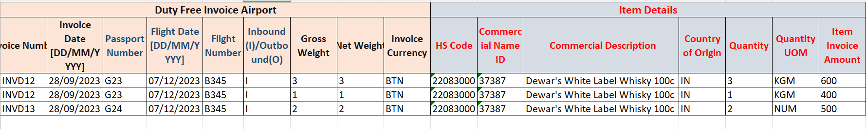
    - Add New invoice and consignor details >> add in the invoice details and commodities details >> Save
    - Here we can upload the excel containing the details , under invoice list and commodity details, all the data will be auto fetched from excel

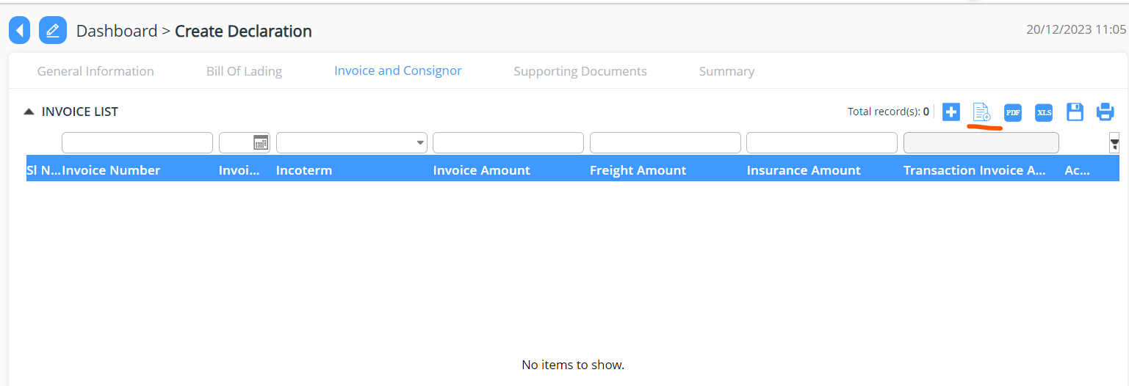
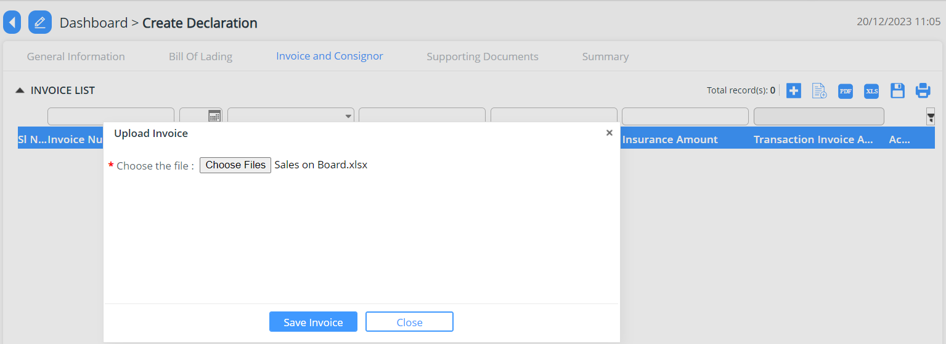

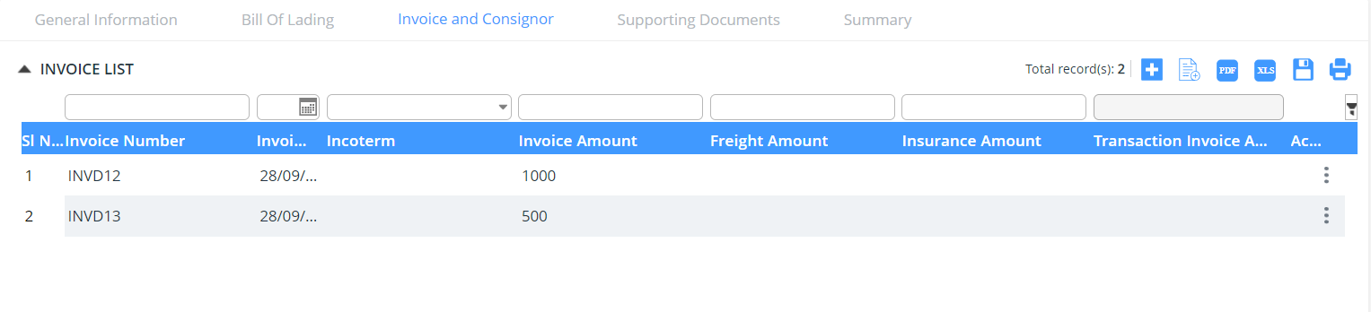
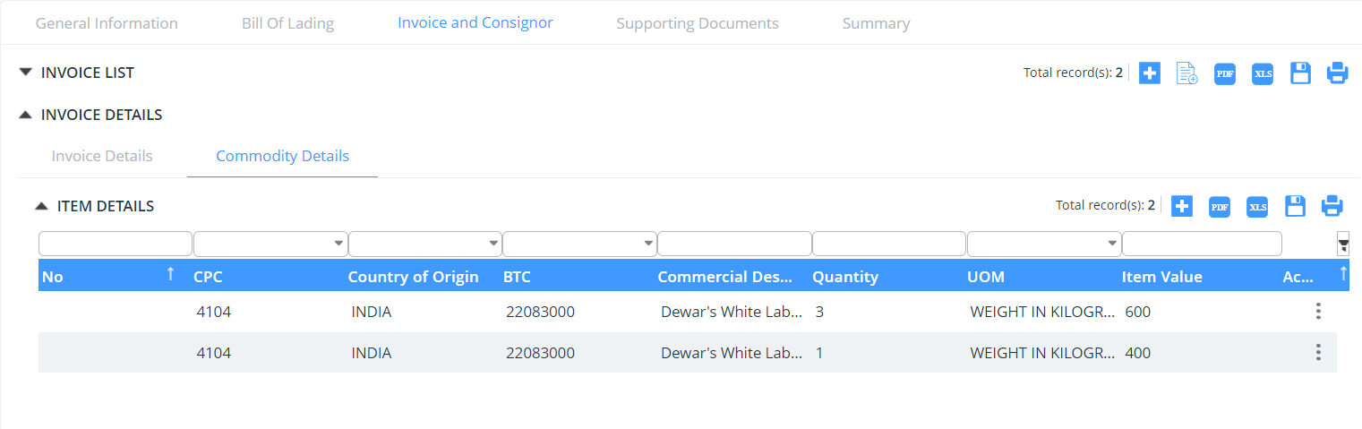
- Supporting document
    - Upload of the mandatory document


- Summary
    - The declarant can review his/her declaration summary and submit the same for approval, here we have the check box to accept the terms and condition.
    - Here the user can validate the declaration before submission- to do so click on Validate Button.
    - While validation if any data has been mistaken, it will be notified in the red ribbon and if all ok then the dialogue box will appear stating the validation



    - The user can submit the declaration which will allow the user to generate the reference declaration number.

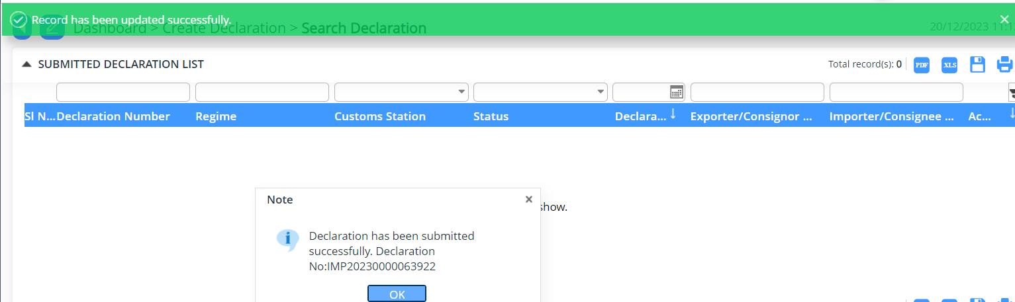

Note: The declaration number generated shall be used to tracking applications

